Installer Manual
QR/NFC (QRC481)
PRODUCT ID reader-QRC481
CATEGORY controller-reader
LANGUAGE EN
VERSION 1.0

INTENDED USE · SAFETY · COMPLIANCE
Safety and compliance
This page summarises the warning blocks commonly included in professional installer manuals for video door entry entrance panels. Symbols, directives and wording must always be aligned with the technical file of the specific model.
Common symbols / replace with official artwork in the final release
These badges are layout placeholders for the manual. CE, WEEE and other regulatory marks should be replaced with the manufacturer’s official vector artwork in the final version.
READ  Read the manual before installation | ATTN  Important warnings and cautions
TECH  Qualified technical personnel only | OFF  Disconnect power before wiring
CE  CE marking where applicable | WEEE  Separate collection / WEEE
SAFETY AND COMPLIANCE
Intended use  Device intended for audio/video communication and access control systems in residential, commercial, industrial and public buildings. Any different use is considered improper. | Qualified installation  Installation, configuration, commissioning and non-routine servicing must be carried out by qualified personnel in accordance with the electrical regulations in force in the country of installation.
Power and wiring  Disconnect power before working on the wiring. Use suitable cables and respect polarity, cross-section and distance limits. Avoid unplanned mixing with mains power lines. | Cleaning and maintenance  Clean with a soft dry cloth or a slightly damp cloth. Do not use alcohol, solvents, sprays or aggressive chemicals. Do not open or tamper with the device unless expressly permitted by the manufacturer.
Compliance documentation  CE marking, EU declarations, applicable directives and radio data must match the technical file of the specific model. Documentation should state where the full declaration of conformity is available. | End-of-life disposal  At the end of its life, the product must be delivered to separate collection channels for electrical and electronic equipment. WEEE information and disposal instructions should be included where applicable.
For versions with Wi‑Fi, Bluetooth, LTE or other radio interfaces, add the EU declaration of conformity reference and the essential radio information required by the model technical file.
Recommended contents inspired by recurring safety sections found in installer manuals from leading video door entry manufacturers.

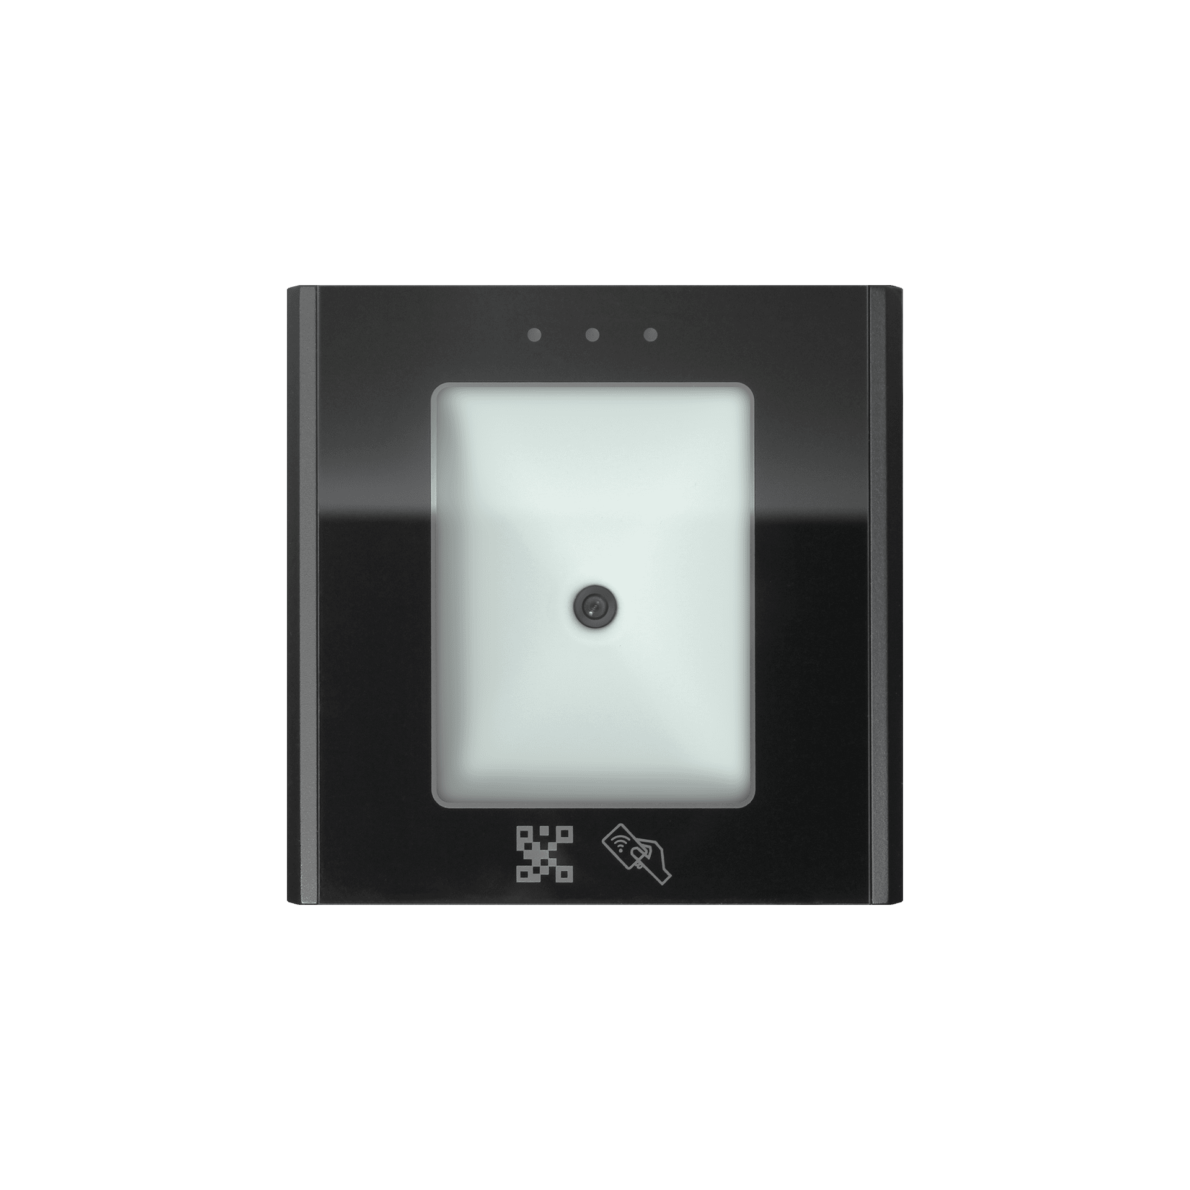

Table of contents

1. Overview

1.1 Description

2. Technical specifications
Technical specifications are provided in tables (source: product specs).

3. Installation

3.1 Introduction
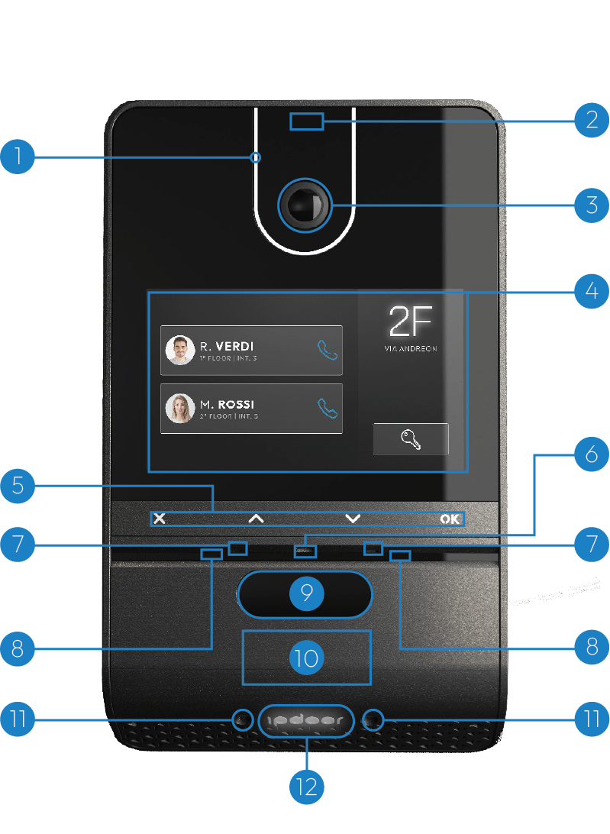
- Front LED light
- Proximity radar
- Panoramic camera
- Touch screen
- Metal keys
- Brightness sensor
- Microphones
- Infrared led
- Facial recognition cameras
- NFC reader
- Lights of the lower
- RGB color illuminated logo

3.2 Mechanical installation

Wall support
Step 1 — Preparation
Place the DIMA on the wall,with the holes at the top at a height from the ground between 155 and 165 cm, making sure that the "TOP" side is facing up. Draw with a pencil the positions of the four holes highlighted in red in the figure.
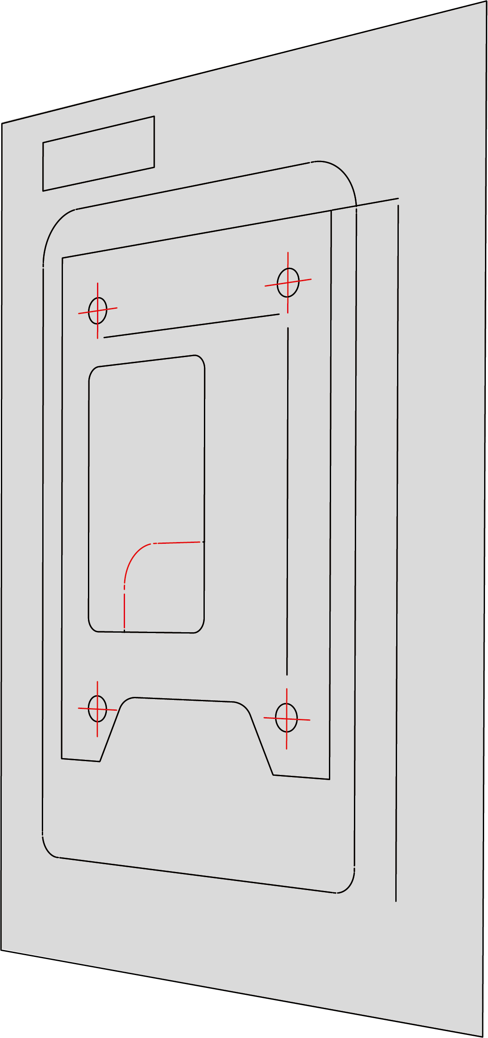
Step 2 — Check
Before proceeding, carefully check that there are no cables or pipes behind the wall, then drill holes in the wall at the previously drawn points.
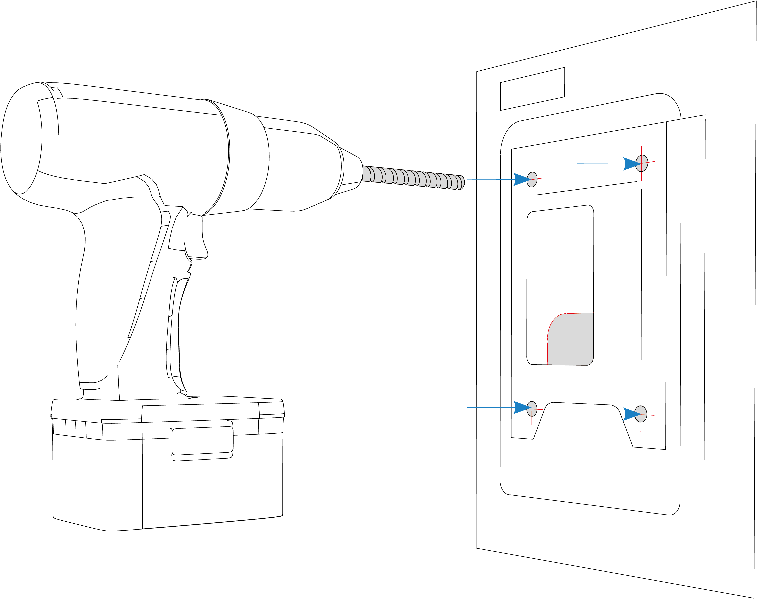
Step 3 — Drilling
Insert the dowels making sure they are perfectly flush with the wall. Then apply the fixing plate and secure it using the four screws provided, as shown in the figure.
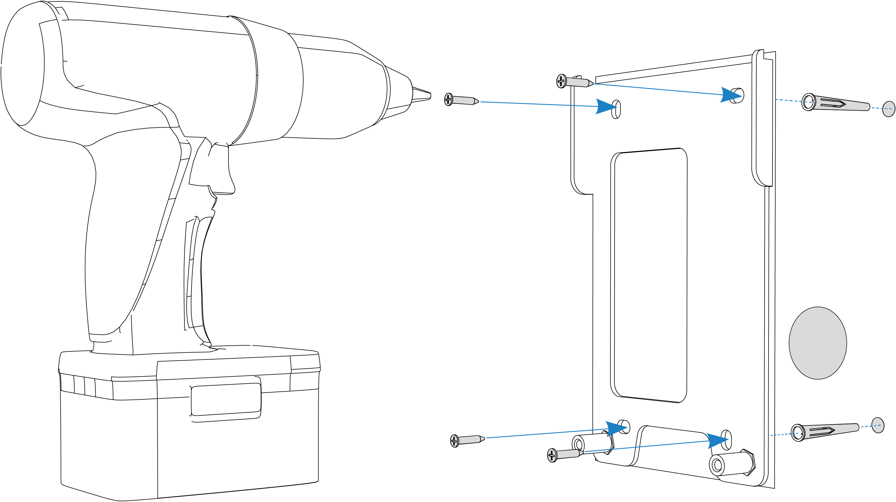
Step 4 — Installation support
To facilitate connections to the terminal block, a stand is available to support the plate during wiring operations. Attach the stand to the plate and tighten the front screw, as shown.
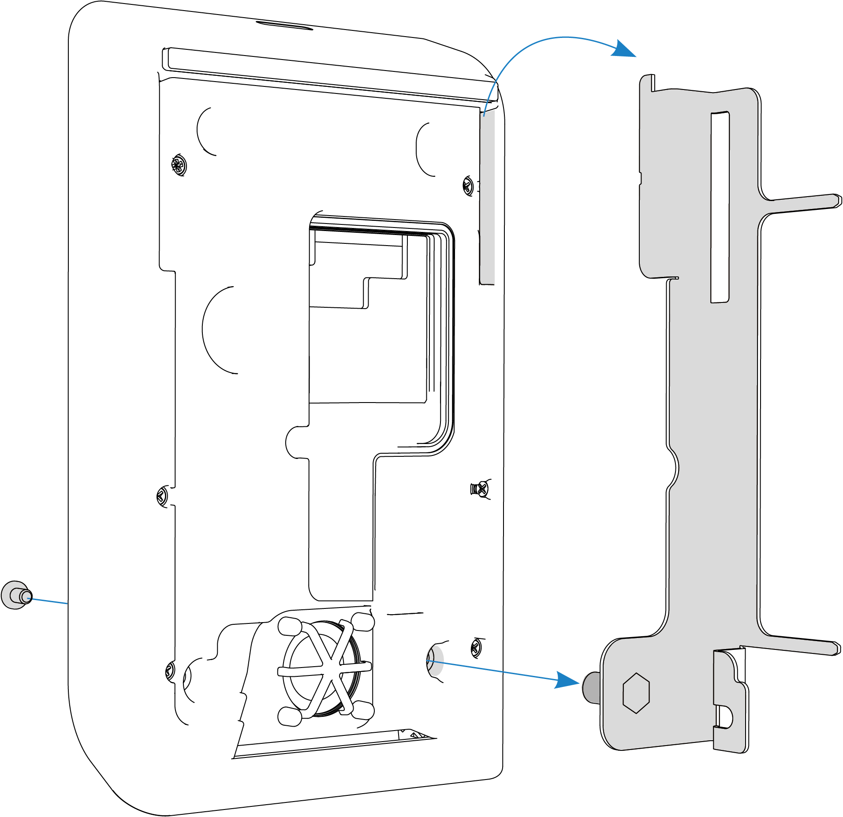
Step 5 — Plate fixing
Then proceed by hooking the stand to the plate and connect the cables to the terminal block. Once the connections are completed, unhook the stand from the plate and then from the device.
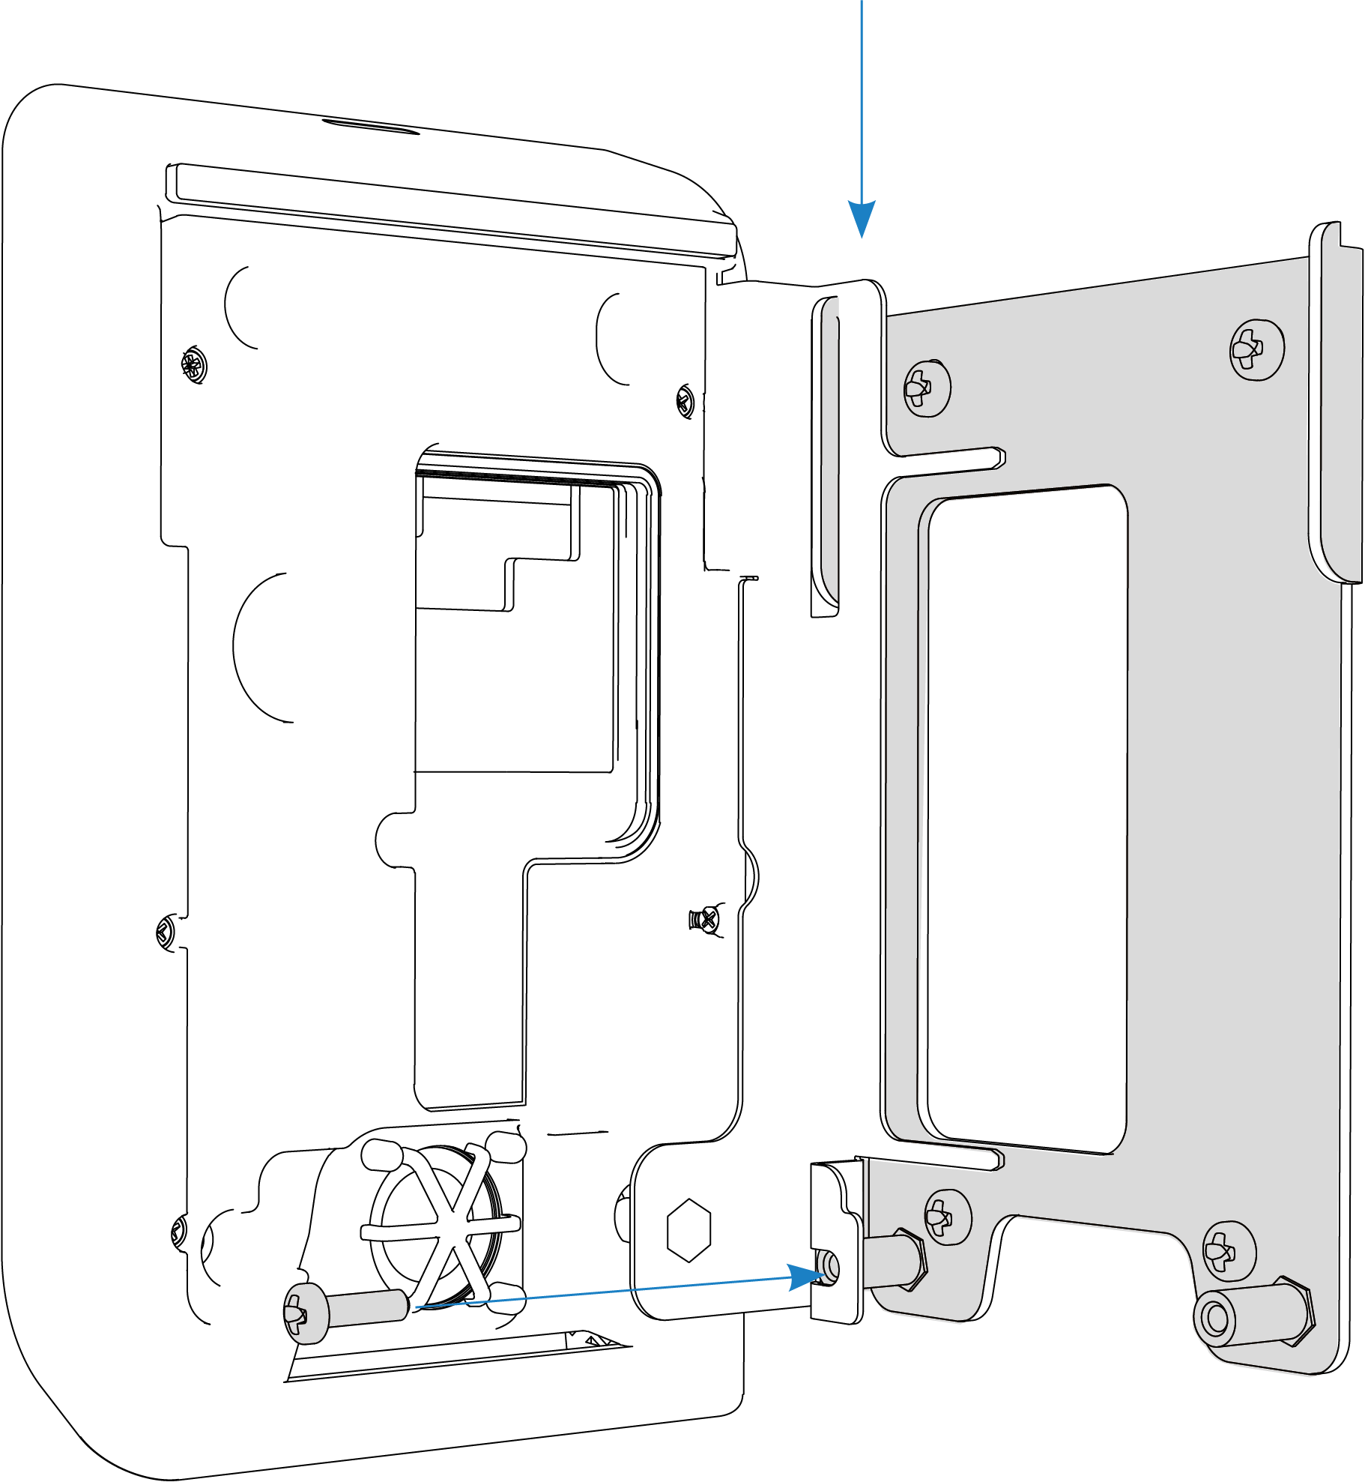
Step 6 — Fixing device
Hook the plate onto the plate and screw in the two front screws as shown in the figure.
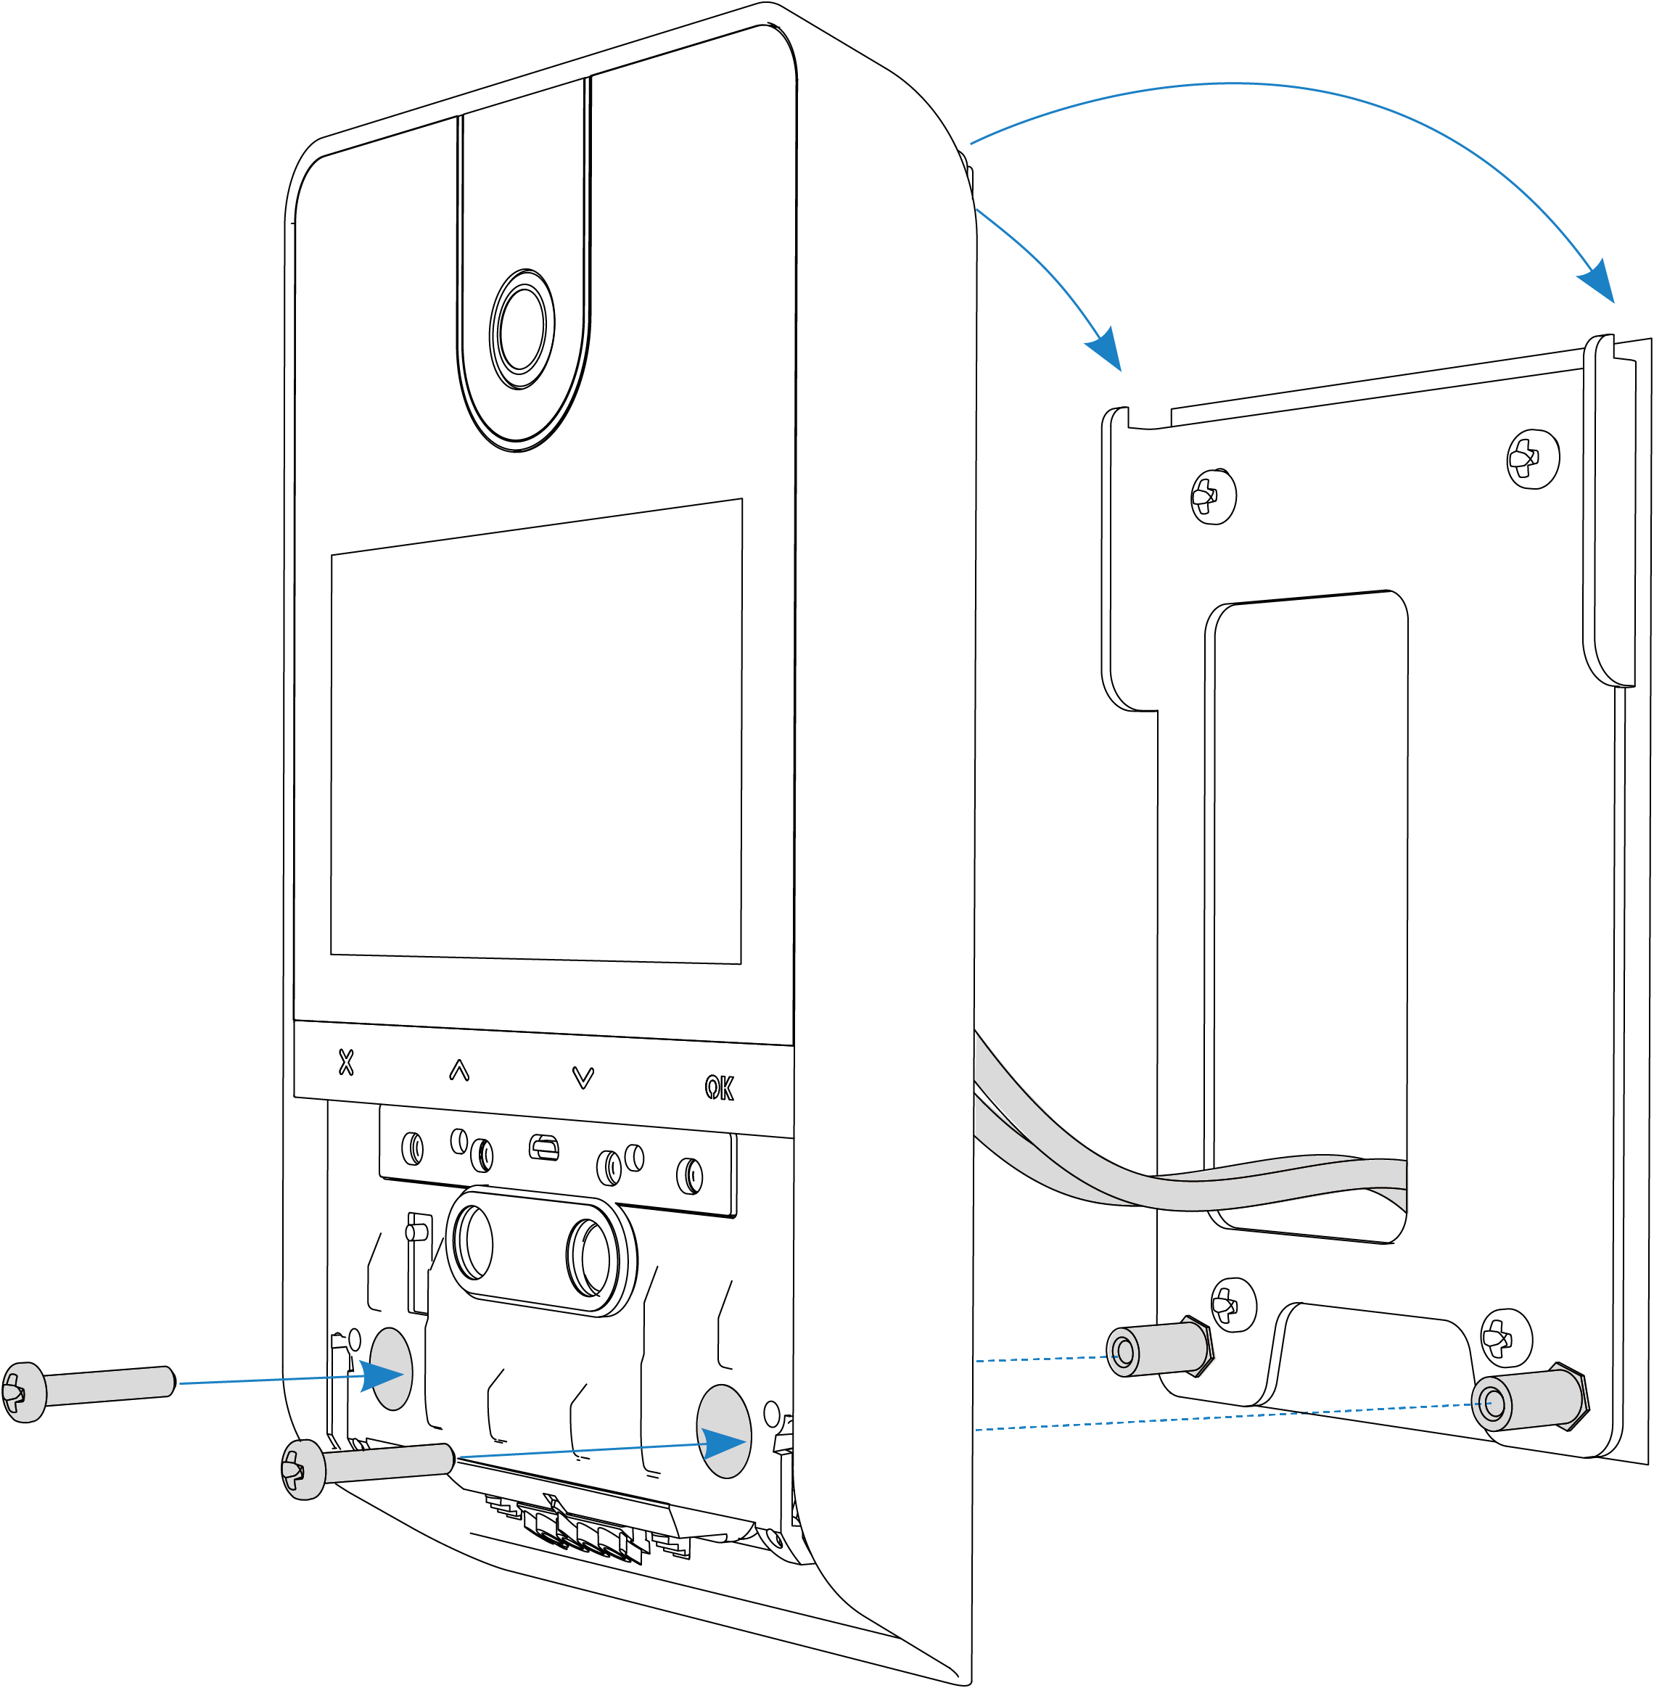
Step 7 — Closing
To complete the installation, insert the cover from bottom to top until you hear it click.
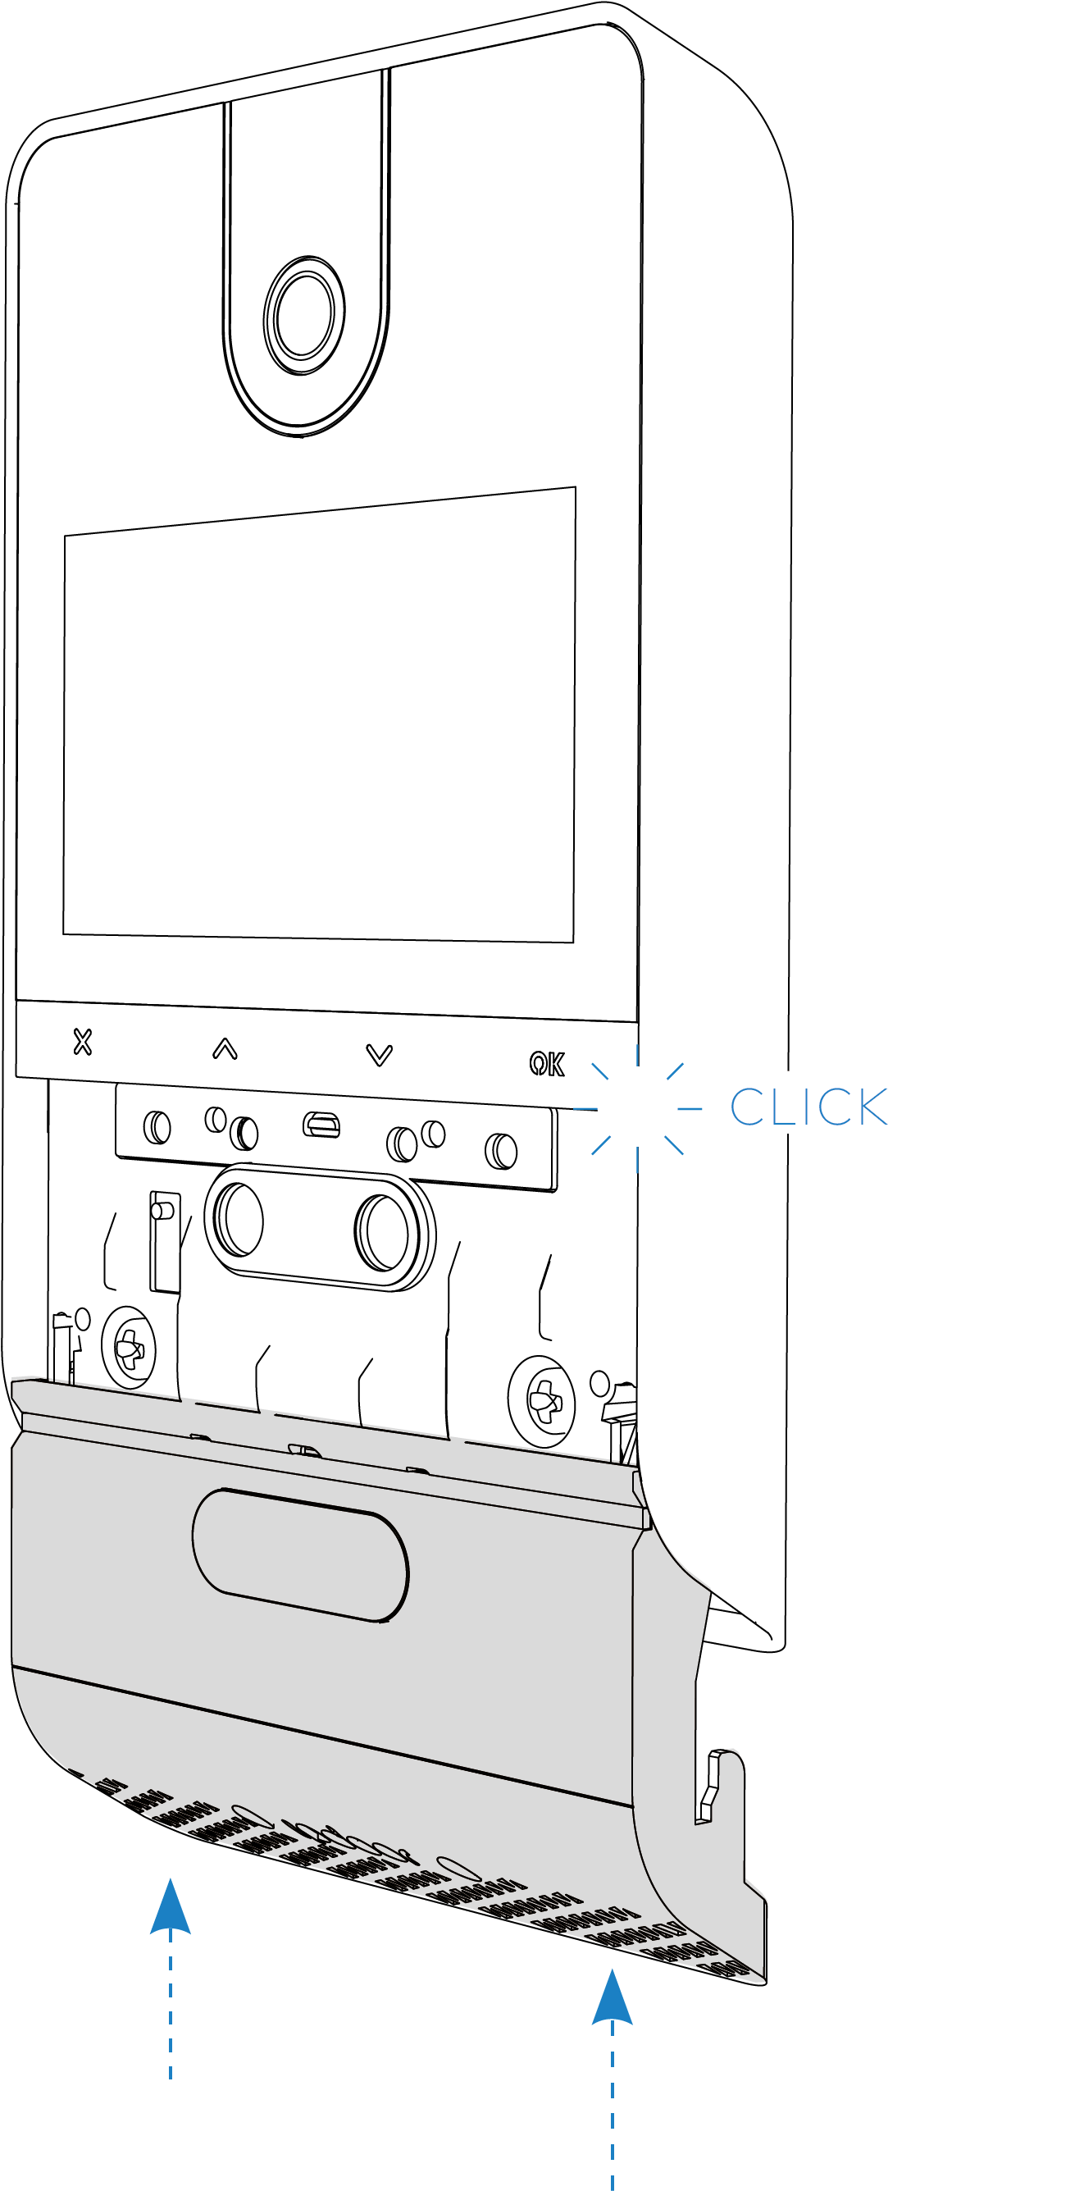
Step 8 — Disassembly
To uninstall the plate, insert the safety wrench into the slot on the bottom of the cover, push the cover down, and unscrew the front screws.
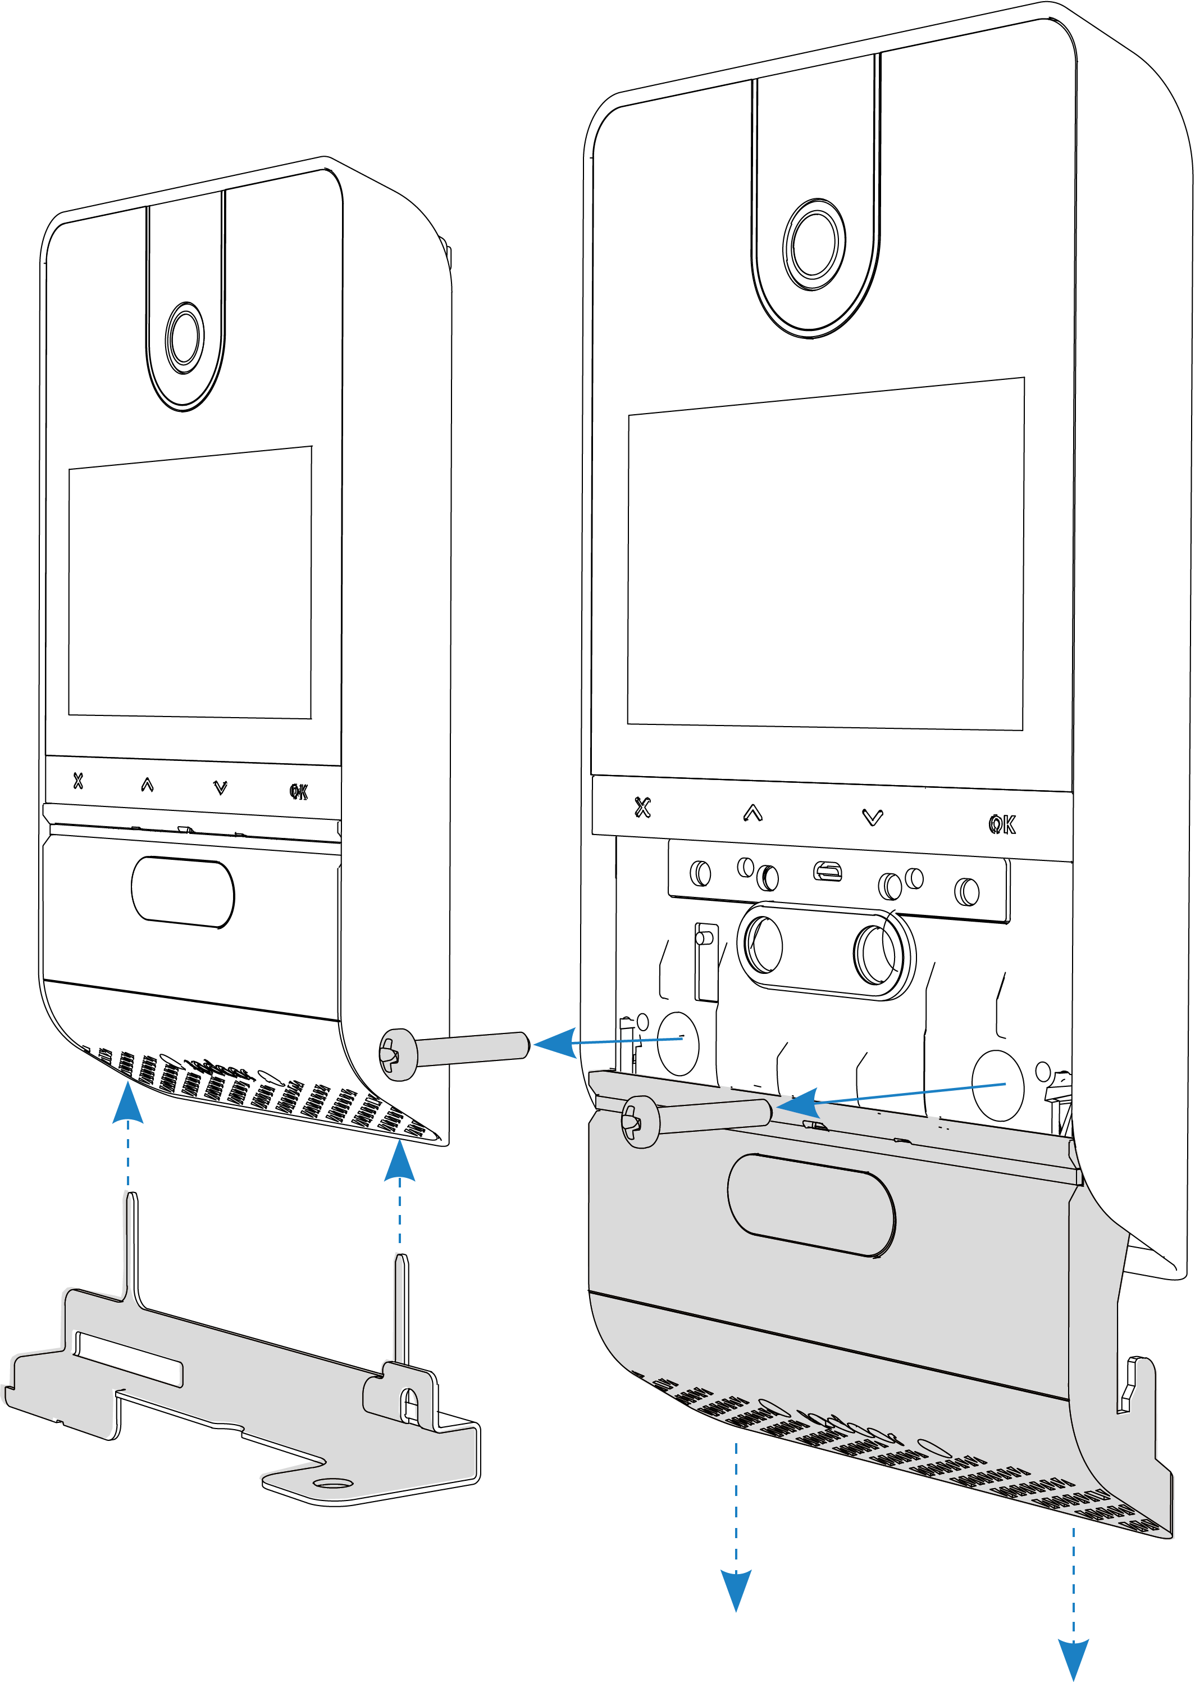

3.3 Wiring
Step 1 — Preparation
WIRING ACCESS: After unscrewing the cover, remove the front screw at the bottom and rotate the holder so that the terminal area can be accessed. Locate the PoE input and other power terminals (as needed as described in the next steps).
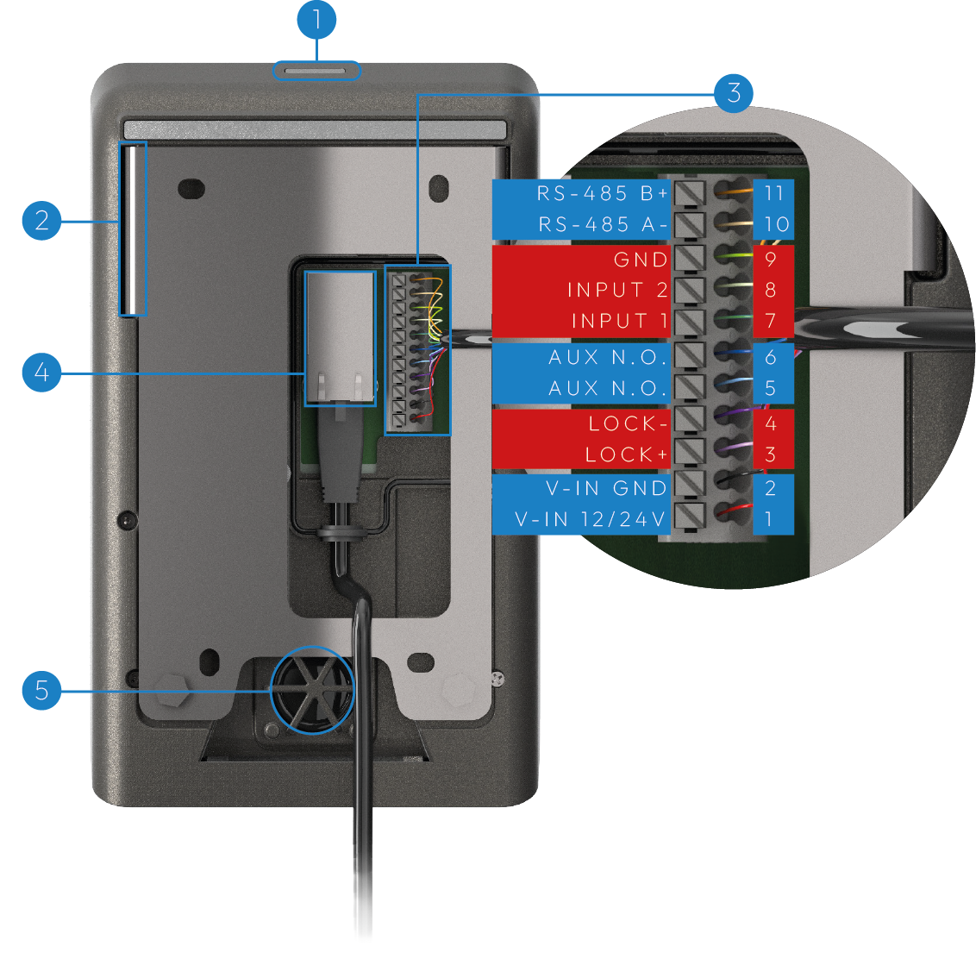
Step 2 — Optional Power Supply
OPTIONAL POWER SUPPLY: If the Ethernet network is not PoE, a 24VDC/1A power supply must be used. Connect the power supply to the terminals indicated.
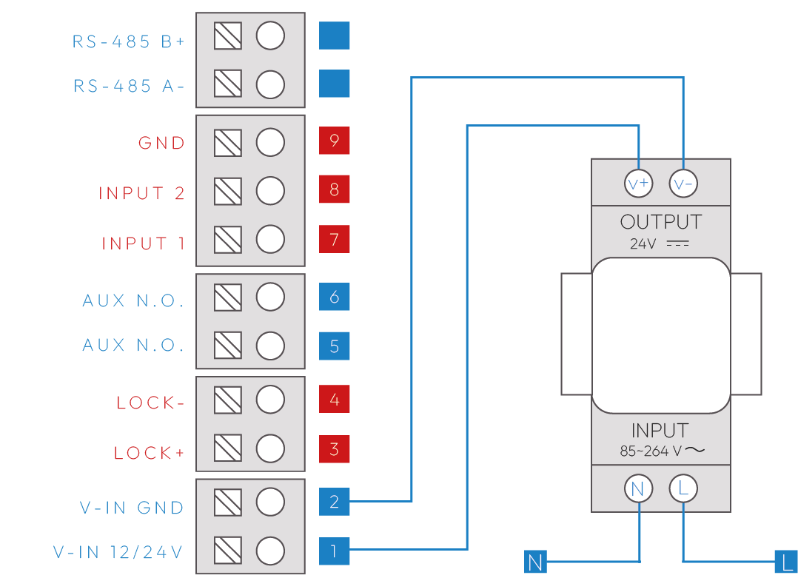
Step 3 — Direct connection Lock
LOCK OUTPUT: An electric lock can be directly connected to the LOCK+ / LOCK- terminals (max 1A, cable ≤30m, 1.5mm²). An intermediate relay must be used for different loads, as shown in the application diagrams.
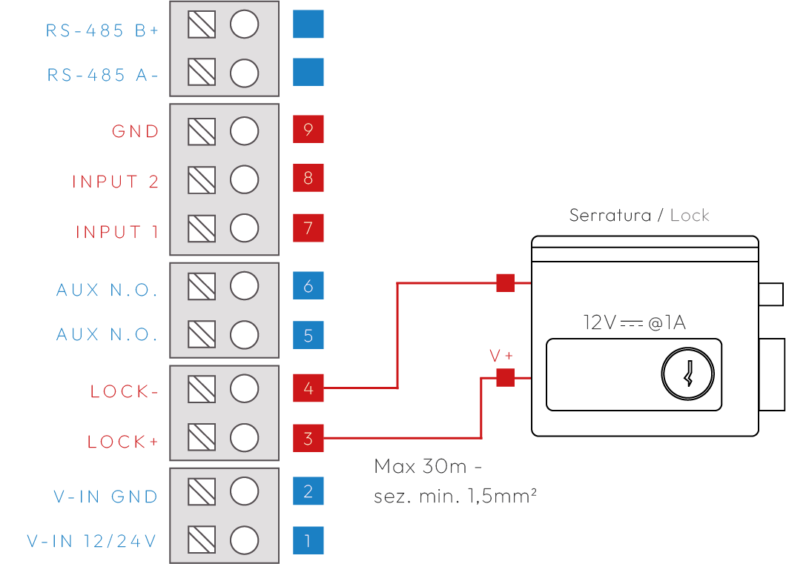
Step 4 — Powered Lock Connection
AUX OUTPUT: In this case the output is a dry contact switch that can drive an external load. If the load is in 220VAC, a power relay must be used.
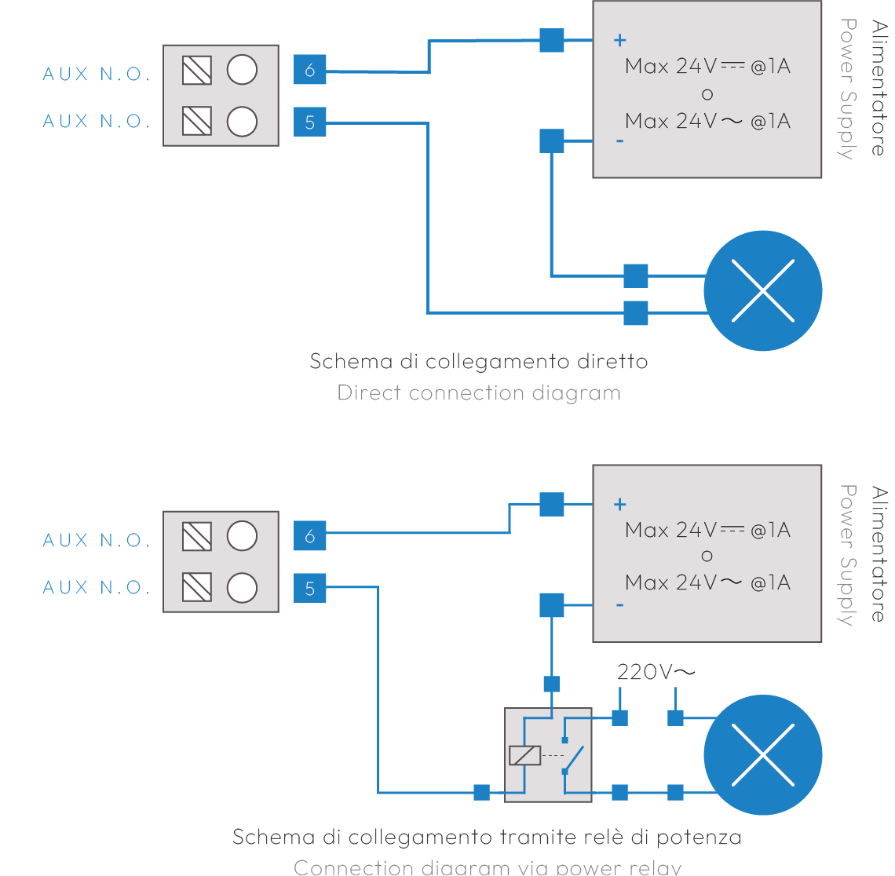
Step 5 — Connecting Button Inputs
INPUTS: Up to two inputs (e.g. external door opener buttons) can be connected. The inputs are programmable. Example of external door opener button on INPUT 1 / GND.
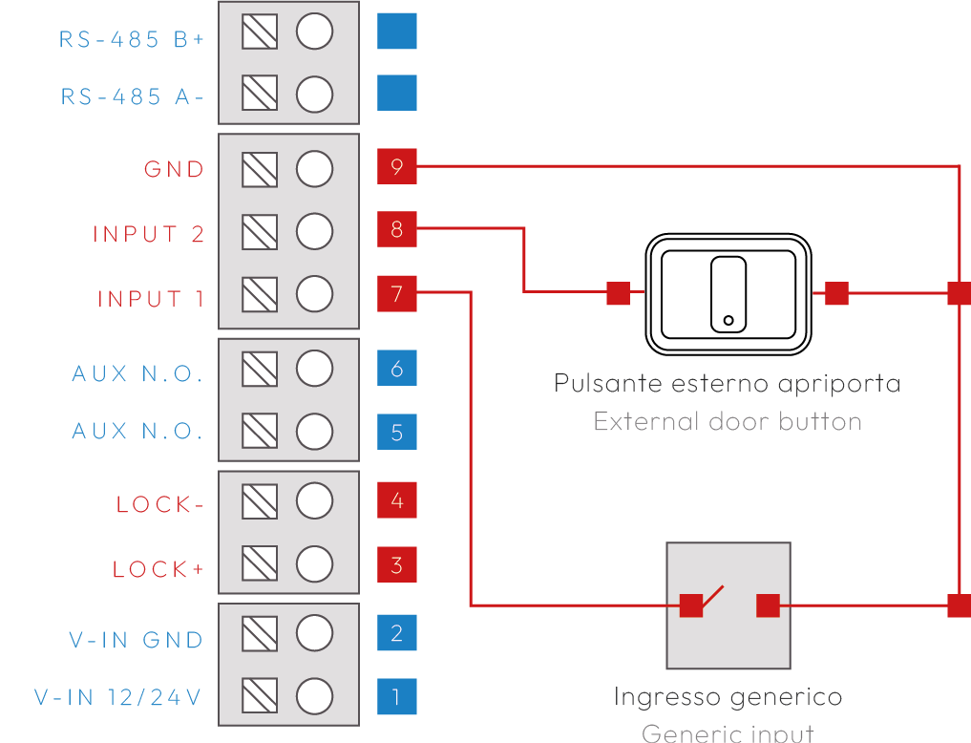

4. Operating notes

4.1 Maintenance
- Clean with a soft cloth.
- Do not use solvents.

5. Revisions
Version | Notes
1.0 | 2026-04-06

