Installer Manual
SPARK 300 - IP wall-mounted outdoor station
SPARK 300 surface mount outdoor station with 4" touch display Equipped with HD camera with panoramic view and QR code reading, motion sensor radar, Ethernet and Wifi network interfaces, Bluetooth and NFC access control interfaces, programmable physical button. Features 1 relay and one powered output, as well as 2 inputs and 485 bus interface IP65 rating Available accessories: facial recognition cameras, LTE card for cellular connection, RF module for remote control function, DDA interface for deaf, memory extension via SD card for local recording.
PRODUCT ID spark-300
CATEGORY door-stations
LANGUAGE EN
VERSION 1.0

INTENDED USE · SAFETY · COMPLIANCE
Safety and compliance
This page summarises the warning blocks commonly included in professional installer manuals for video door entry entrance panels. Symbols, directives and wording must always be aligned with the technical file of the specific model.
Common symbols / replace with official artwork in the final release
These badges are layout placeholders for the manual. CE, WEEE and other regulatory marks should be replaced with the manufacturer’s official vector artwork in the final version.
READ  Read the manual before installation | ATTN  Important warnings and cautions
TECH  Qualified technical personnel only | OFF  Disconnect power before wiring
CE  CE marking where applicable | WEEE  Separate collection / WEEE
SAFETY AND COMPLIANCE
Intended use  Device intended for audio/video communication and access control systems in residential, commercial, industrial and public buildings. Any different use is considered improper. | Qualified installation  Installation, configuration, commissioning and non-routine servicing must be carried out by qualified personnel in accordance with the electrical regulations in force in the country of installation.
Power and wiring  Disconnect power before working on the wiring. Use suitable cables and respect polarity, cross-section and distance limits. Avoid unplanned mixing with mains power lines. | Cleaning and maintenance  Clean with a soft dry cloth or a slightly damp cloth. Do not use alcohol, solvents, sprays or aggressive chemicals. Do not open or tamper with the device unless expressly permitted by the manufacturer.
Compliance documentation  CE marking, EU declarations, applicable directives and radio data must match the technical file of the specific model. Documentation should state where the full declaration of conformity is available. | End-of-life disposal  At the end of its life, the product must be delivered to separate collection channels for electrical and electronic equipment. WEEE information and disposal instructions should be included where applicable.
For versions with Wi‑Fi, Bluetooth, LTE or other radio interfaces, add the EU declaration of conformity reference and the essential radio information required by the model technical file.
Recommended contents inspired by recurring safety sections found in installer manuals from leading video door entry manufacturers.

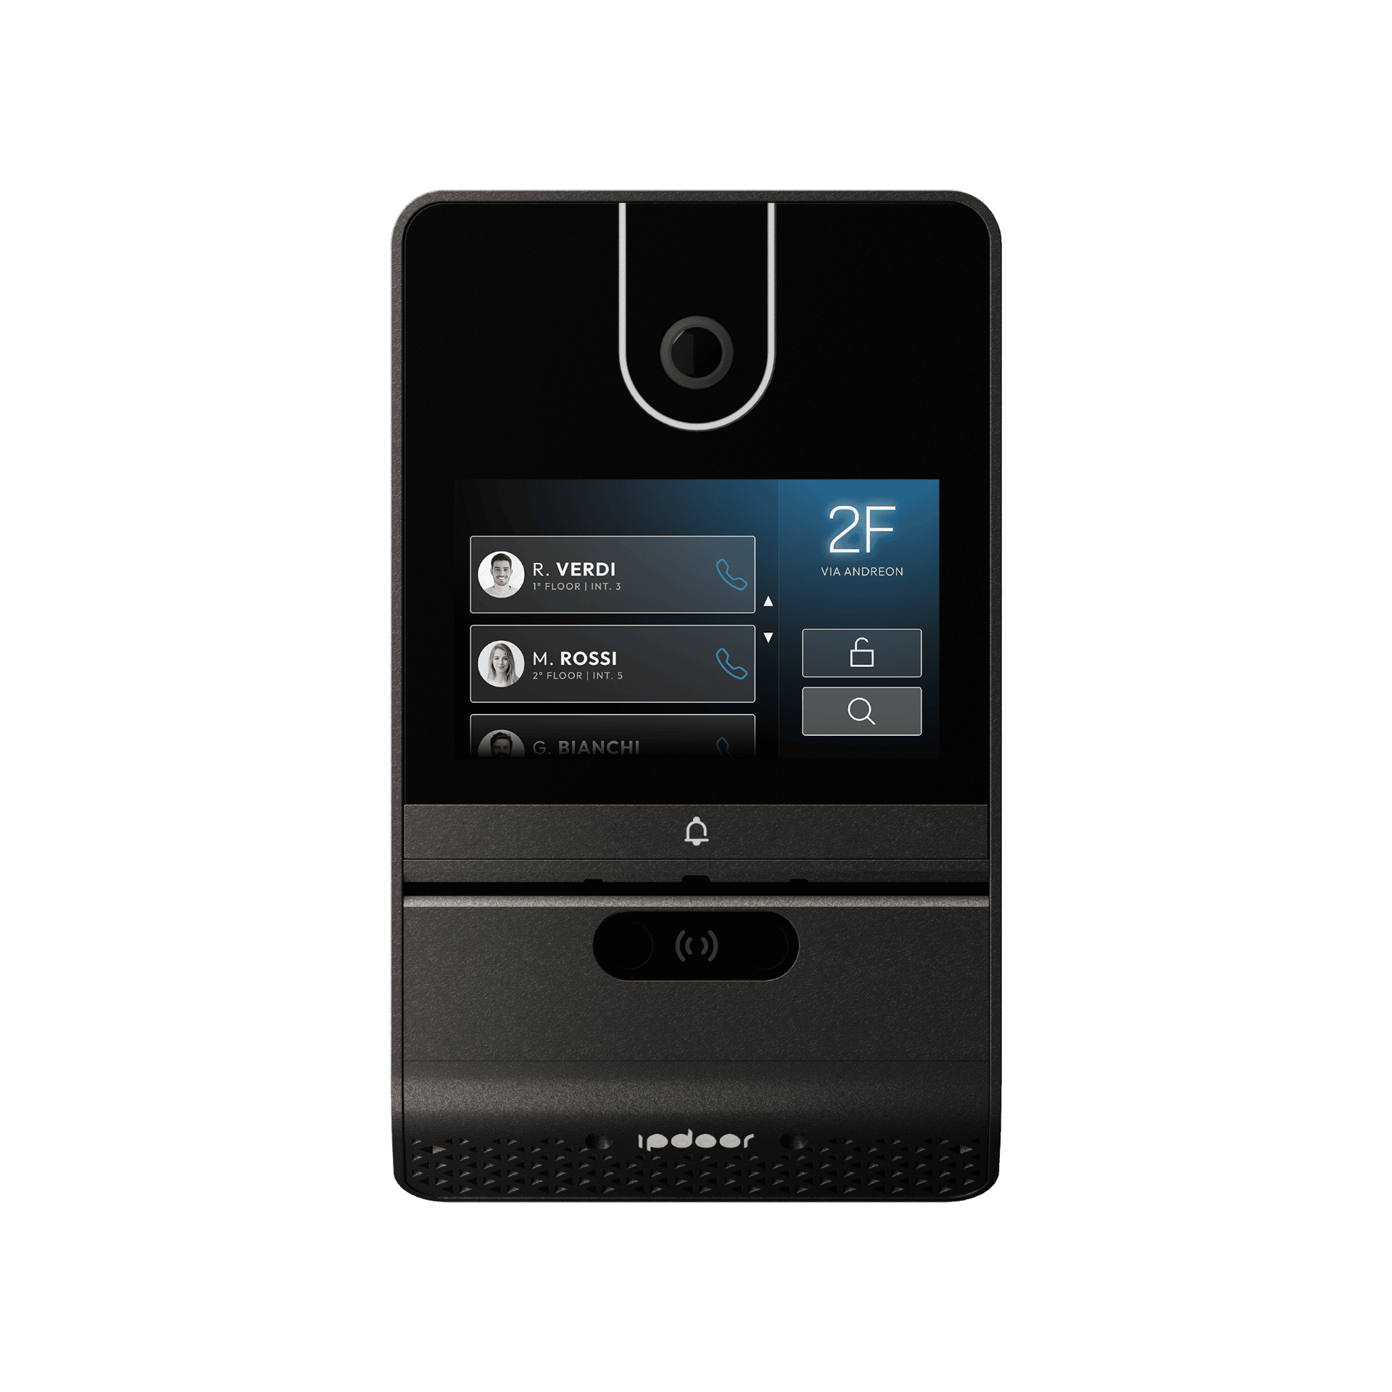
SPARK 300 surface mount outdoor station with 4" touch display Equipped with HD camera with panoramic view and QR code reading, motion sensor radar, Ethernet and Wifi network interfaces, Bluetooth and NFC access control interfaces, programmable physical button. Features 1 relay and one powered output, as well as 2 inputs and 485 bus interface IP65 rating Available accessories: facial recognition cameras, LTE card for cellular connection, RF module for remote control function, DDA interface for deaf, memory extension via SD card for local recording.

Table of contents

1. Overview

1.1 Description
SPARK 300 surface mount outdoor station with 4" touch display Equipped with HD camera with panoramic view and QR code reading, motion sensor radar, Ethernet and Wifi network interfaces, Bluetooth and NFC access control interfaces, programmable physical button. Features 1 relay and one powered output, as well as 2 inputs and 485 bus interface IP65 rating Available accessories: facial recognition cameras, LTE card for cellular connection, RF module for remote control function, DDA interface for deaf, memory extension via SD card for local recording.

1.3 Key features
- Intuitive touchscreen interface that allows the device to be used as a video intercom or as a keypad for access counter
- Multiple interfaces for access control (PIN,QR,NFC,Bluetooth,Facial Recognition
- High-quality audio communication using DSP for audio filters
- Video communication with panoramic view camera that also frames sideways
- Extremely solid metal construction and design

2. Technical specifications
Technical specifications are provided in tables (source: product specs).

General
Parameter | Value
Model | SPARK 300
Type | External IP video intercom device
Installation | Exterior Wall
Available colors | Gray Shadow,Silver
Height | 187 mm
Width | 113 mm
Thickness | 30 mm
Weight | 850 g
Material | Painted metal
Working environments | -20°C / +55°C

Power supply
Parameter | Value
PoE | 802.3af
External power supply | 12/24 V DC @ 1 A
Consumption | 2.5 W (Standby) / 5 W (Max)

Display
Parameter | Value
Dimensions | 4"
Touch screen | YES, capacitive rain-proof
Resolution | 1280 × 720
Brightness | 1100 cd/m²
Type | IPS

Video camera
Parameter | Value
Resolution | 2576 × 1456
Viewing angle | H=170° - V=90°
Sensor | 1/3" CMOS
Sensitivity | Color 0.02 Lux - B/W 0 Lux with active IR
IR illumination | 4 LED IR coverage 5 m

Audio
Parameter | Value
Speaker | 1 × 2 W
Microphones | 2 Digital
DSP | AEC, ANS, AGC

Network and connectivity
Parameter | Value
Ethernet | RJ45 10/100 Mbps
Wi-Fi | Dual band 2.4/5 GHz IEEE 802.11 b/g/n/ac
Bluetooth | 4.2 / BLE
NFC | 13.56 MHz, MIFARE Classic, Ultralight, Plus, DESFire
RS485 | Master/Slave, ASCII/Modbus RTU
LTE | Optional

Inputs and outputs
Parameter | Value
Lock output | 12 V DC @ 1 A impulsive
Auxiliary relay | NO dry contact, 24 V DC @ 2 A max, monostable 1-30 sec.
Inputs | 2 opto-isolated Pull-up inputs

Integrated sensors
Parameter | Value
Movement | Radar, distance and direction up to 5 m
Vandalism | Shock and vibration sensor
Tampering | Forced opening sensor

Certifications
Parameter | Value
Protection | IP65 / IK07

Optional Modules
Parameter | Value
LTE connectivity | LTE module for data connectivity
Facial recognition | Dual camera module for access control based on face recognition
Hearing aid interface | HL/IDL audio induction circuit
RF remote control | 433 MHz transceiver module
SD card | Memory expansion via microSD card.

3. Installation

3.1 Introduction
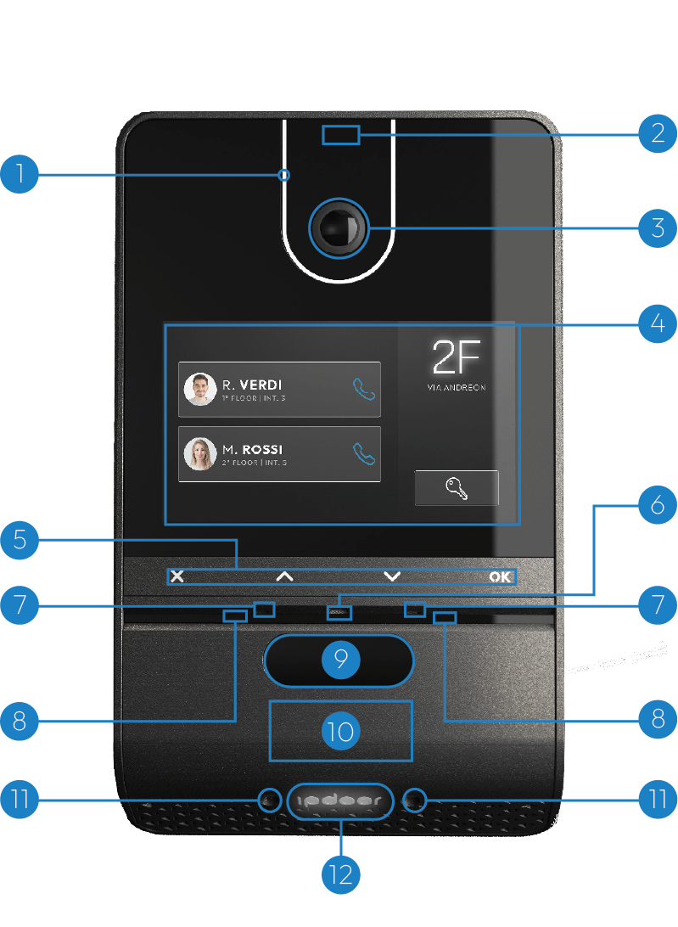
- Front LED light
- Proximity radar
- Panoramic camera
- Touch screen
- Metal keys
- Brightness sensor
- Microphones
- Infrared led
- Facial recognition cameras
- NFC reader
- Lights of the lower
- RGB color illuminated logo

3.2 Mechanical installation

Wall support
Step 1 — Preparation
Place the DIMA on the wall,with the holes at the top at a height from the ground between 155 and 165 cm, making sure that the "TOP" side is facing up. Draw with a pencil the positions of the four holes highlighted in red in the figure.
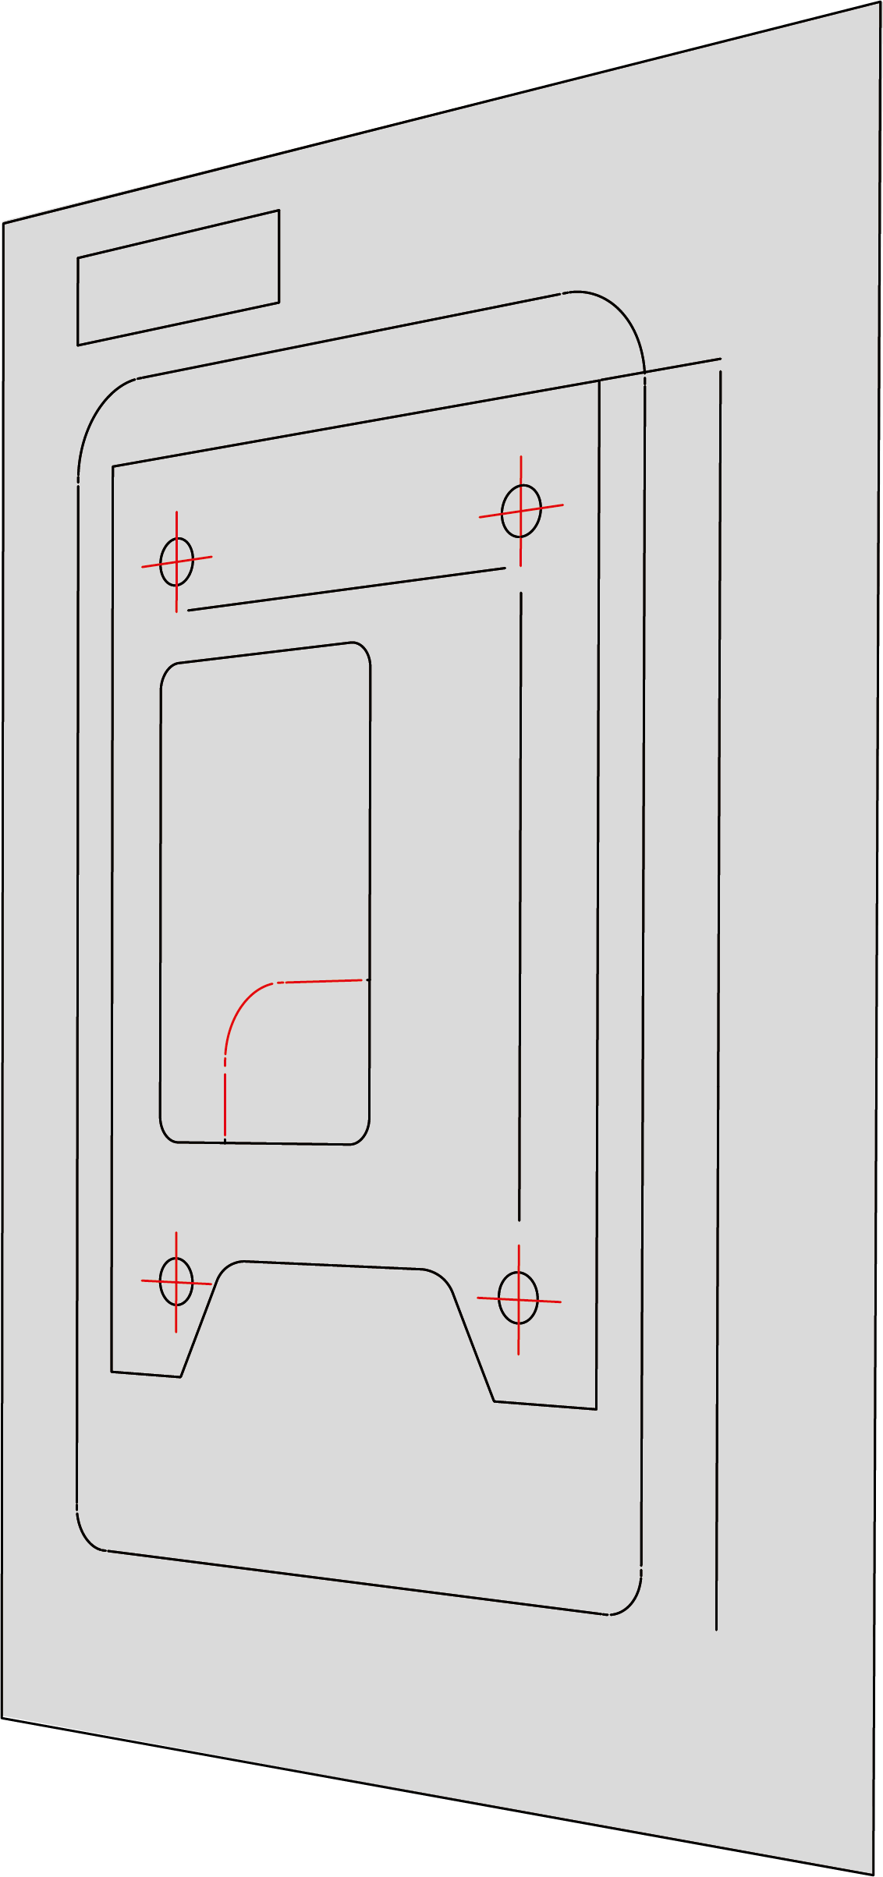
Step 2 — Check
Before proceeding, carefully check that there are no cables or pipes behind the wall, then drill holes in the wall at the previously drawn points.
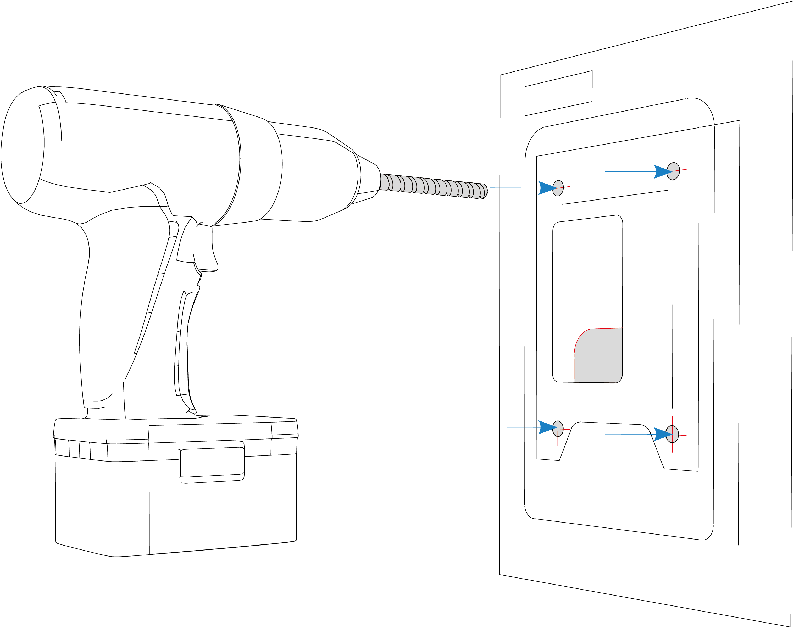
Step 3 — Drilling
Insert the dowels making sure they are perfectly flush with the wall. Then apply the fixing plate and secure it using the four screws provided, as shown in the figure.
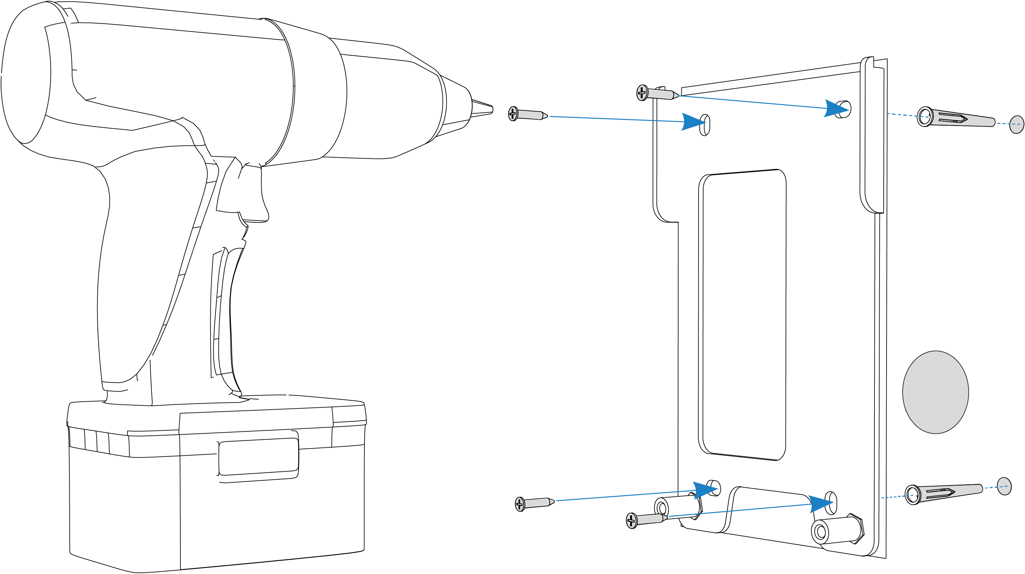
Step 4 — Installation support
To facilitate connections to the terminal block, a stand is available to support the plate during wiring operations. Attach the stand to the plate and tighten the front screw, as shown.
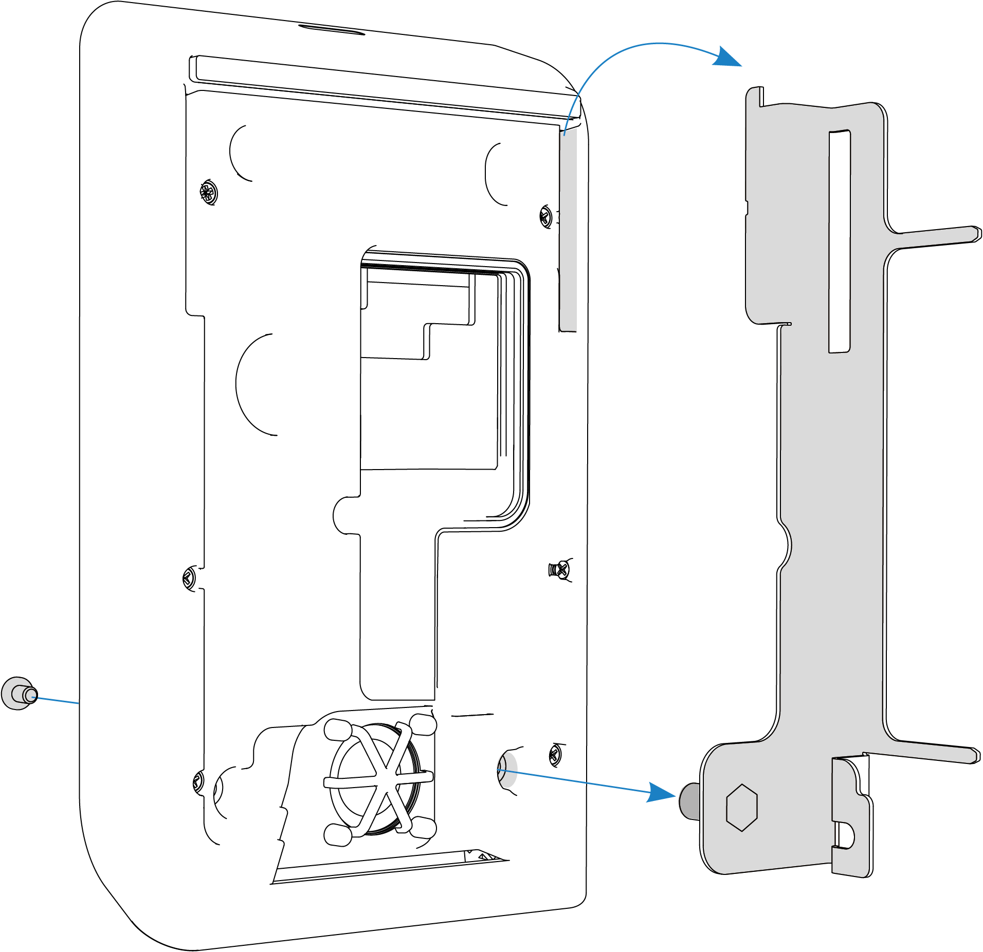
Step 5 — Plate fixing
Then proceed by hooking the stand to the plate and connect the cables to the terminal block. Once the connections are completed, unhook the stand from the plate and then from the device.
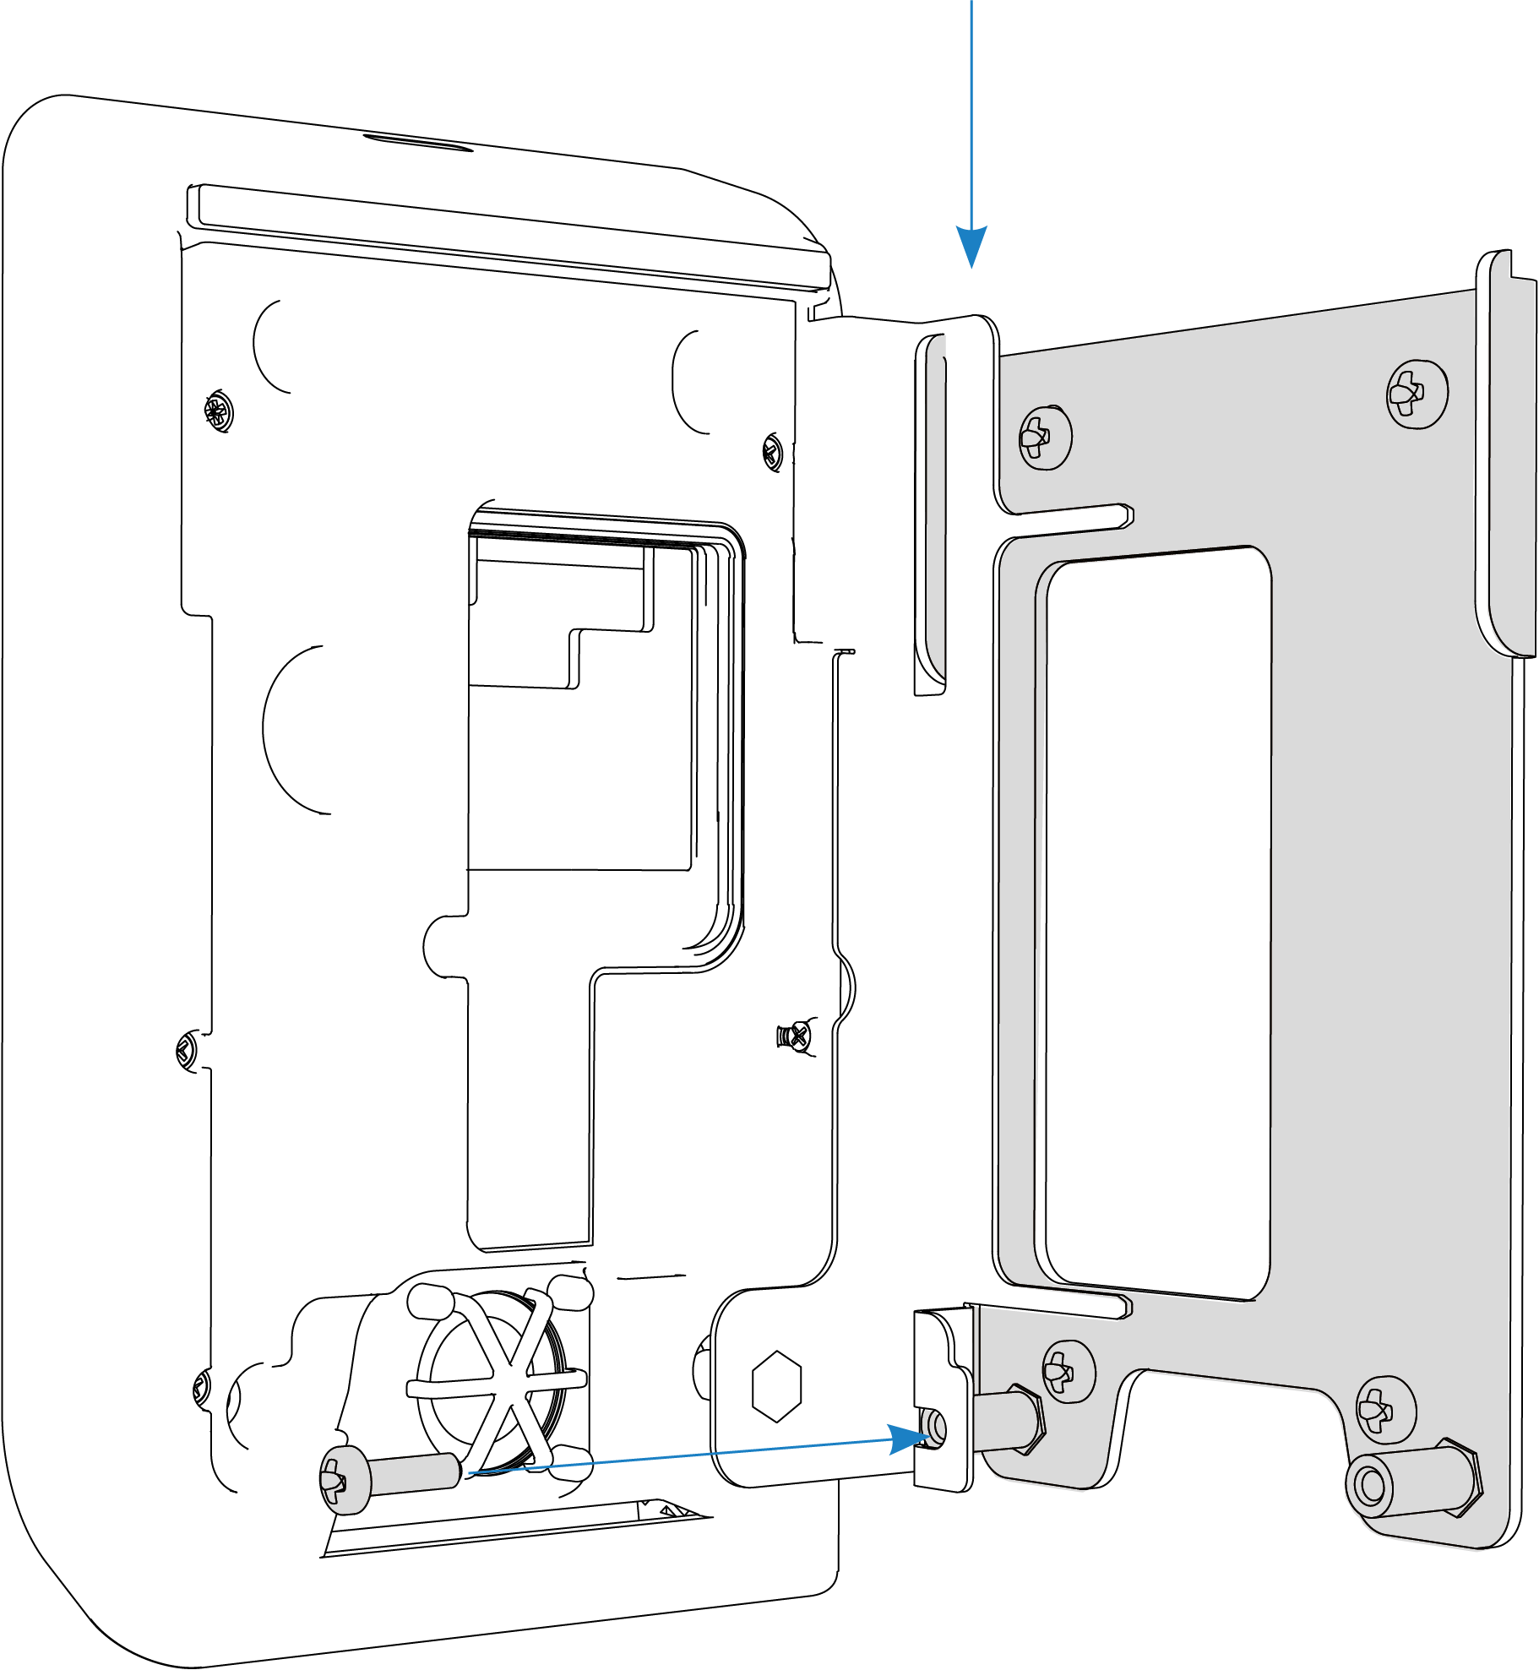
Step 6 — Fixing device
Hook the plate onto the plate and screw in the two front screws as shown in the figure.
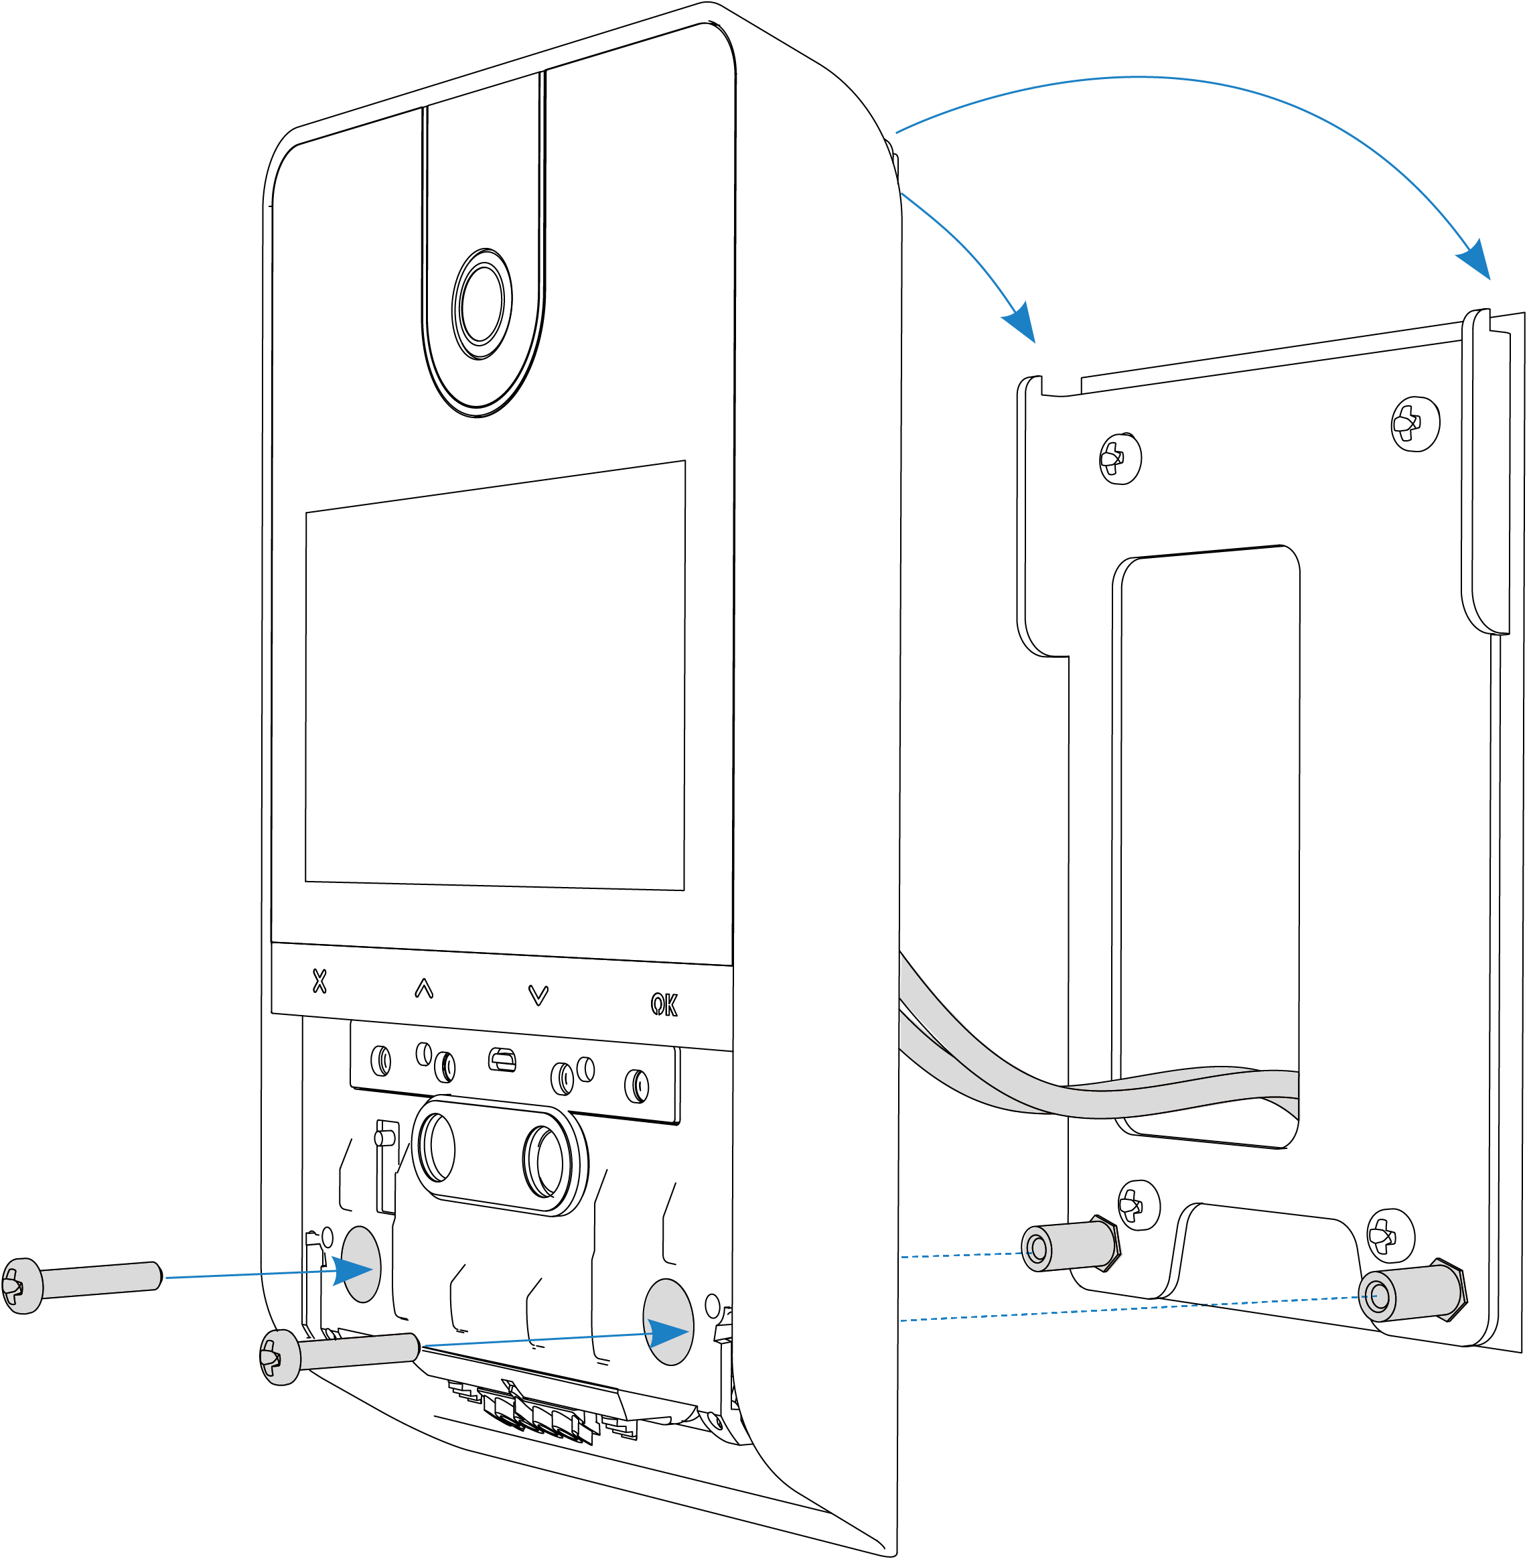
Step 7 — Closing
To complete the installation, insert the cover from bottom to top until you hear it click.
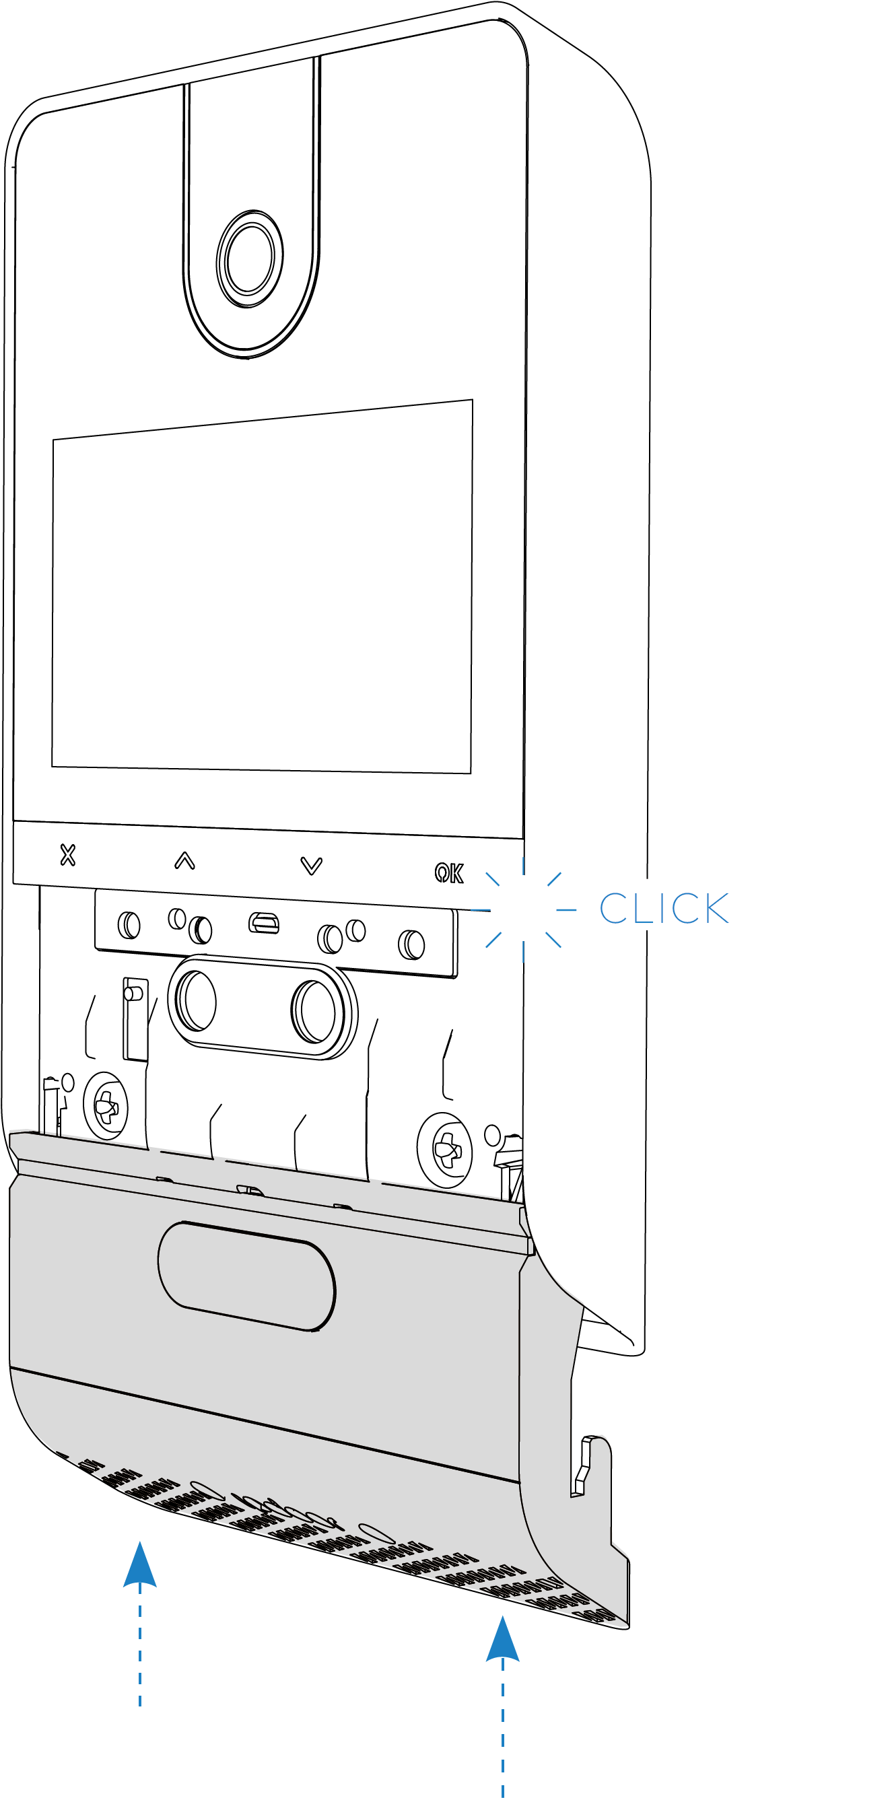
Step 8 — Disassembly
To uninstall the plate, insert the safety wrench into the slot on the bottom of the cover, push the cover down, and unscrew the front screws.
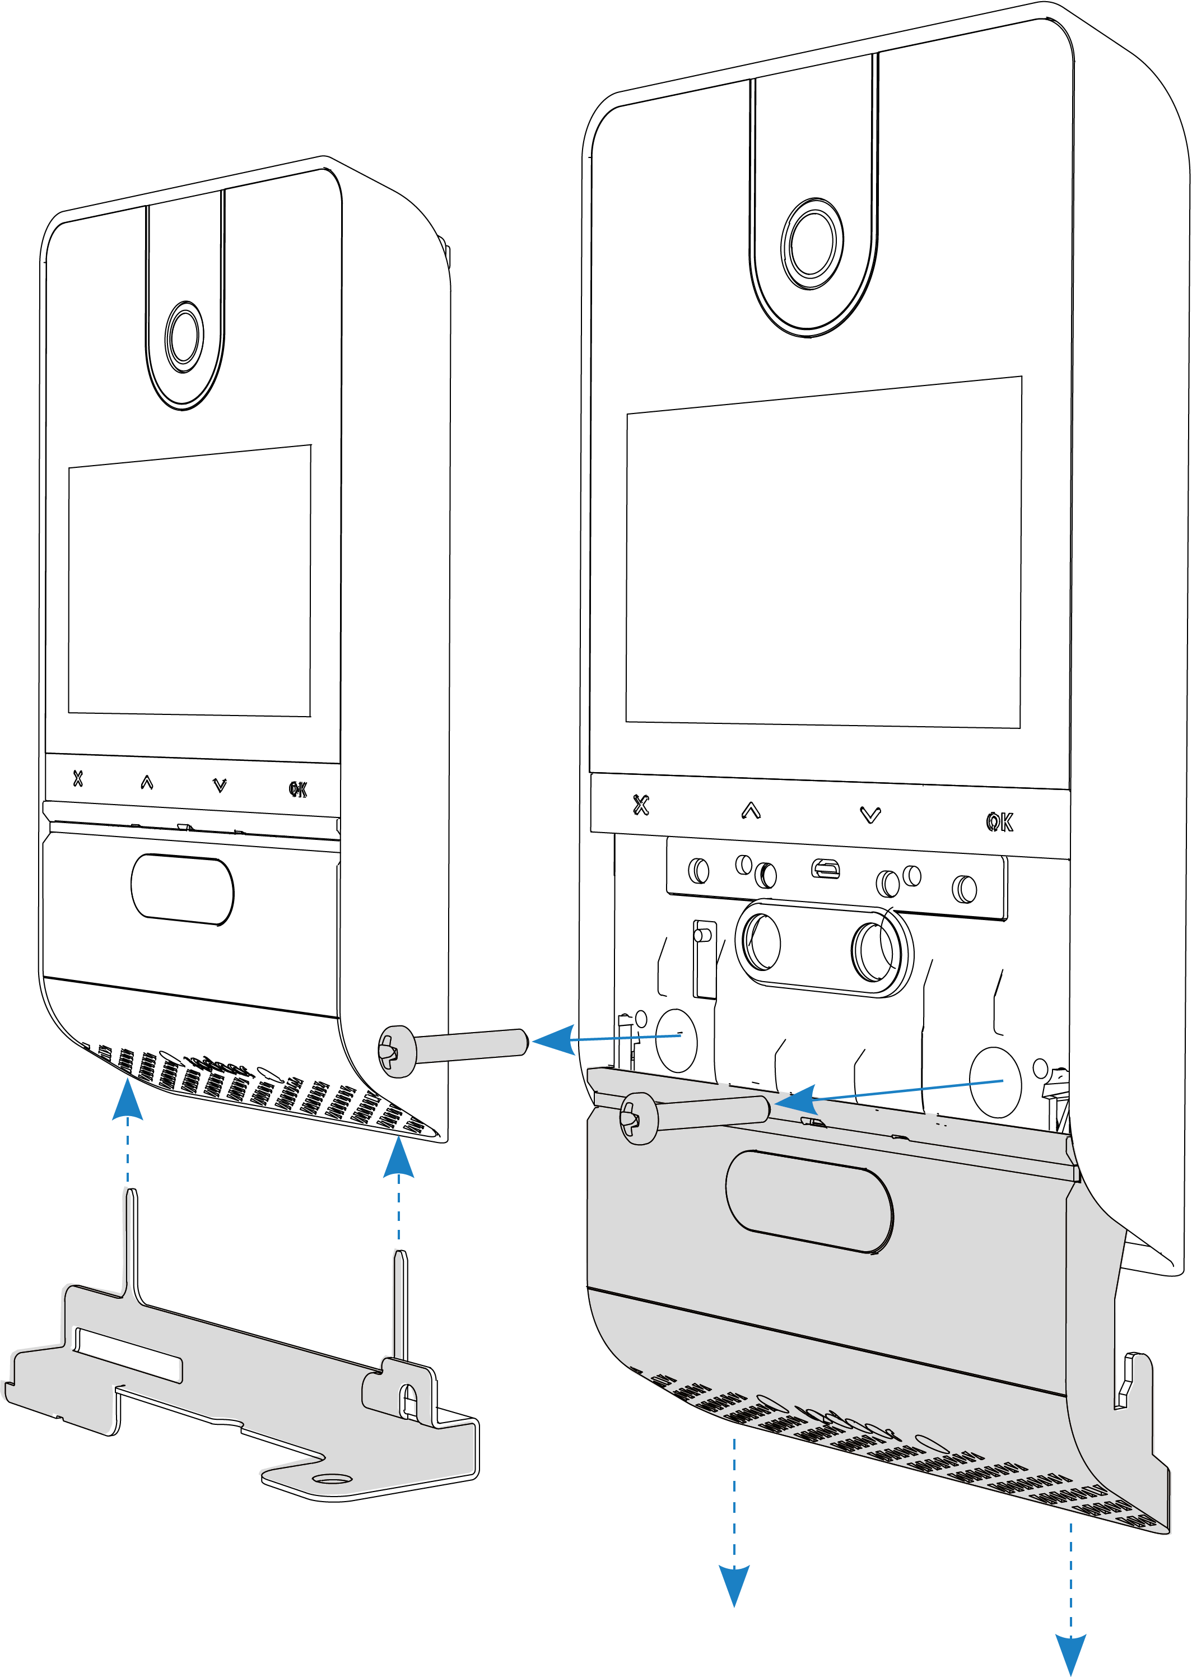

3.3 Wiring
Step 1 — Preparation
WIRING ACCESS: After unscrewing the cover, remove the front screw at the bottom and rotate the holder so that the terminal area can be accessed. Locate the PoE input and other power terminals (as needed as described in the next steps).
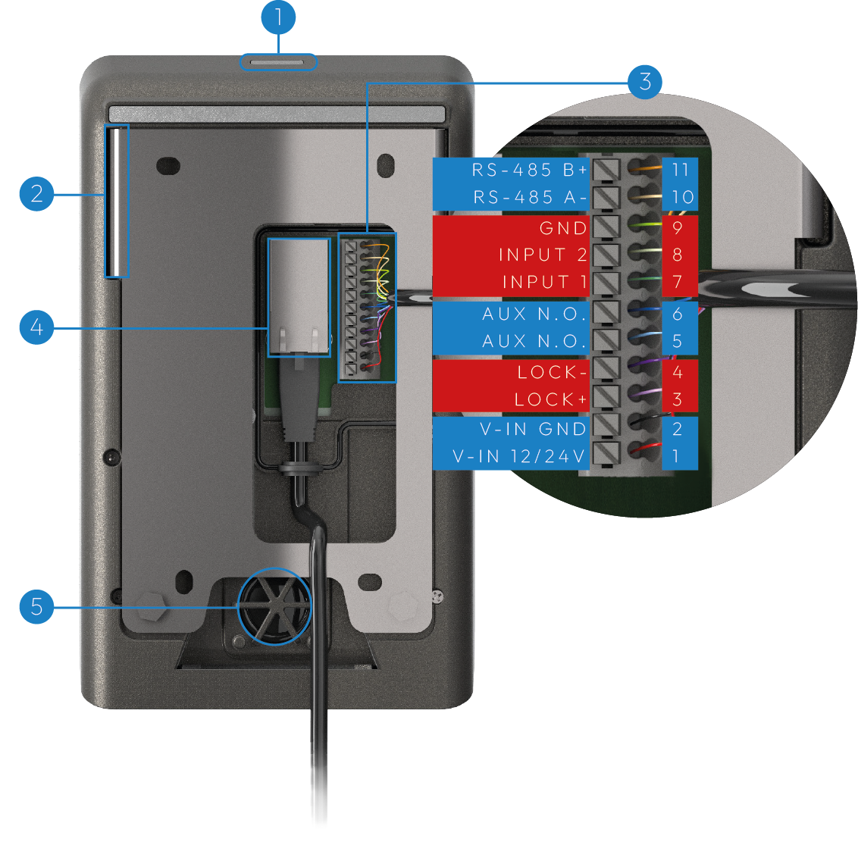
Step 2 — Optional Power Supply
OPTIONAL POWER SUPPLY: If the Ethernet network is not PoE, a 24VDC/1A power supply must be used. Connect the power supply to the terminals indicated.
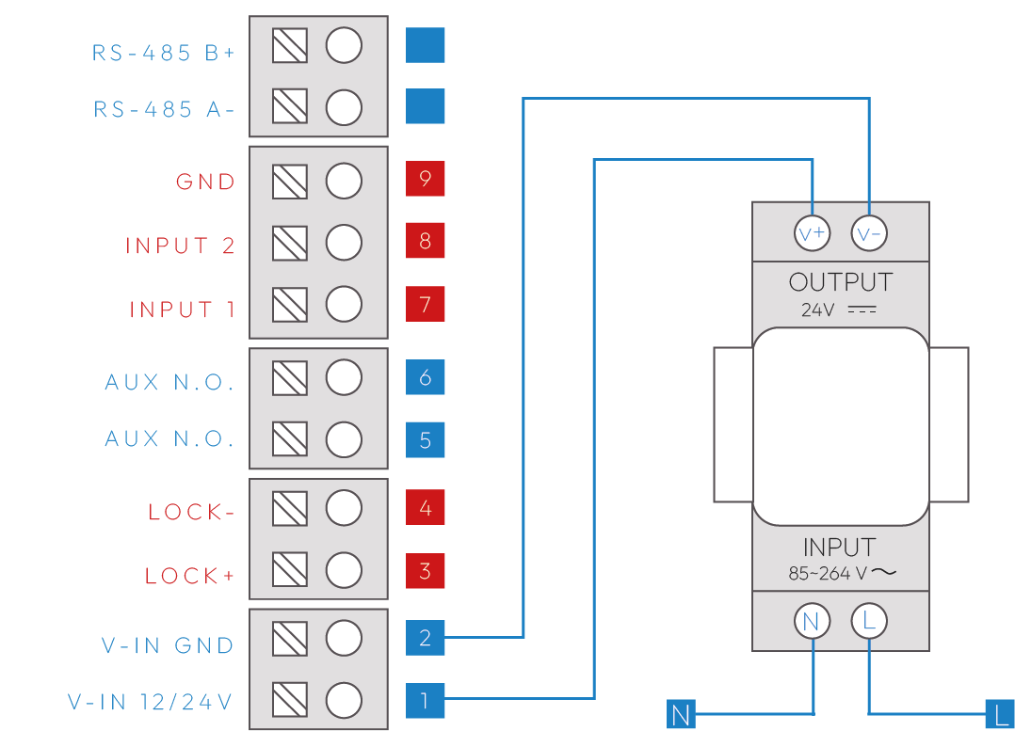
Step 3 — Direct connection Lock
LOCK OUTPUT: An electric lock can be directly connected to the LOCK+ / LOCK- terminals (max 1A, cable ≤30m, 1.5mm²). An intermediate relay must be used for different loads, as shown in the application diagrams.
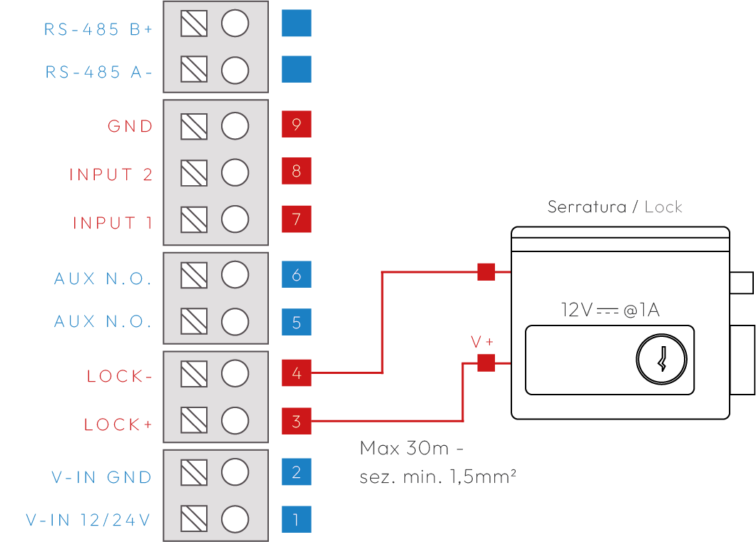
Step 4 — Powered Lock Connection
AUX OUTPUT: In this case the output is a dry contact switch that can drive an external load. If the load is in 220VAC, a power relay must be used.
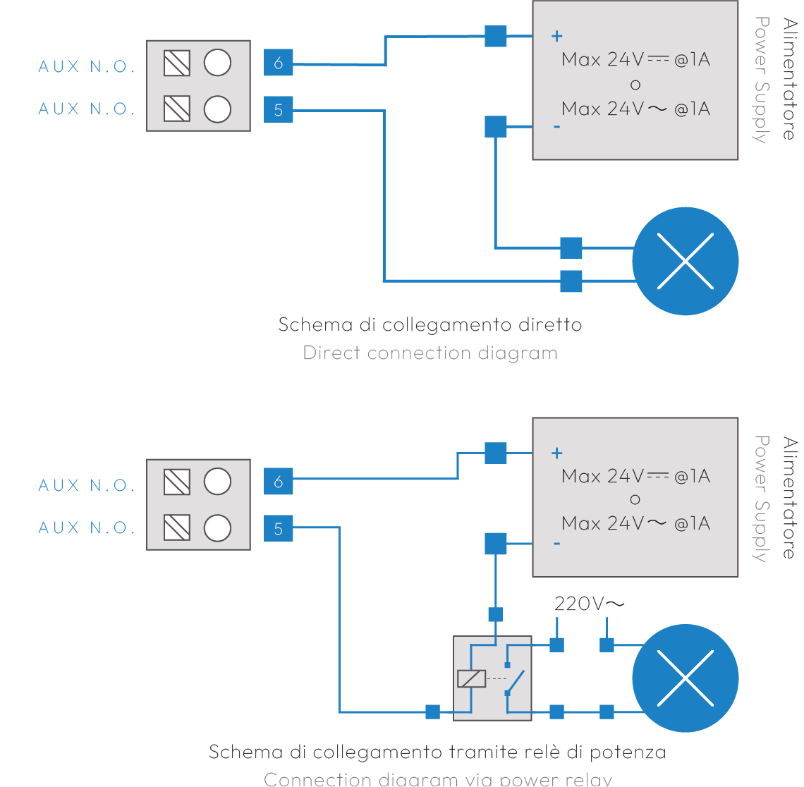
Step 5 — Connecting Button Inputs
INPUTS: Up to two inputs (e.g. external door opener buttons) can be connected. The inputs are programmable. Example of external door opener button on INPUT 1 / GND.
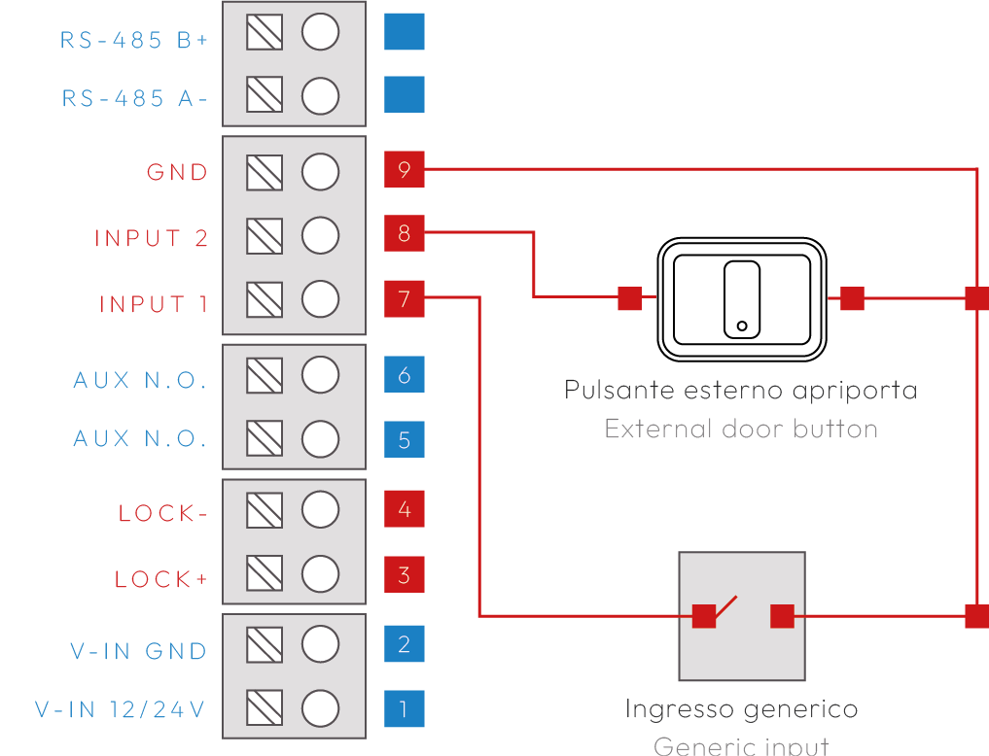

4. Operating notes

4.1 Maintenance
- Clean with a soft cloth.
- Do not use solvents.

5. Revisions
Version | Notes
1.0 | 2026-04-06

